**Introduction to R and RStudio**

Welcome to “Introduction to R and RStudio.” After watching this video, you will be able to explain what is R, list R capabilities, describe RStudio environment, and list the R libraries for data science.

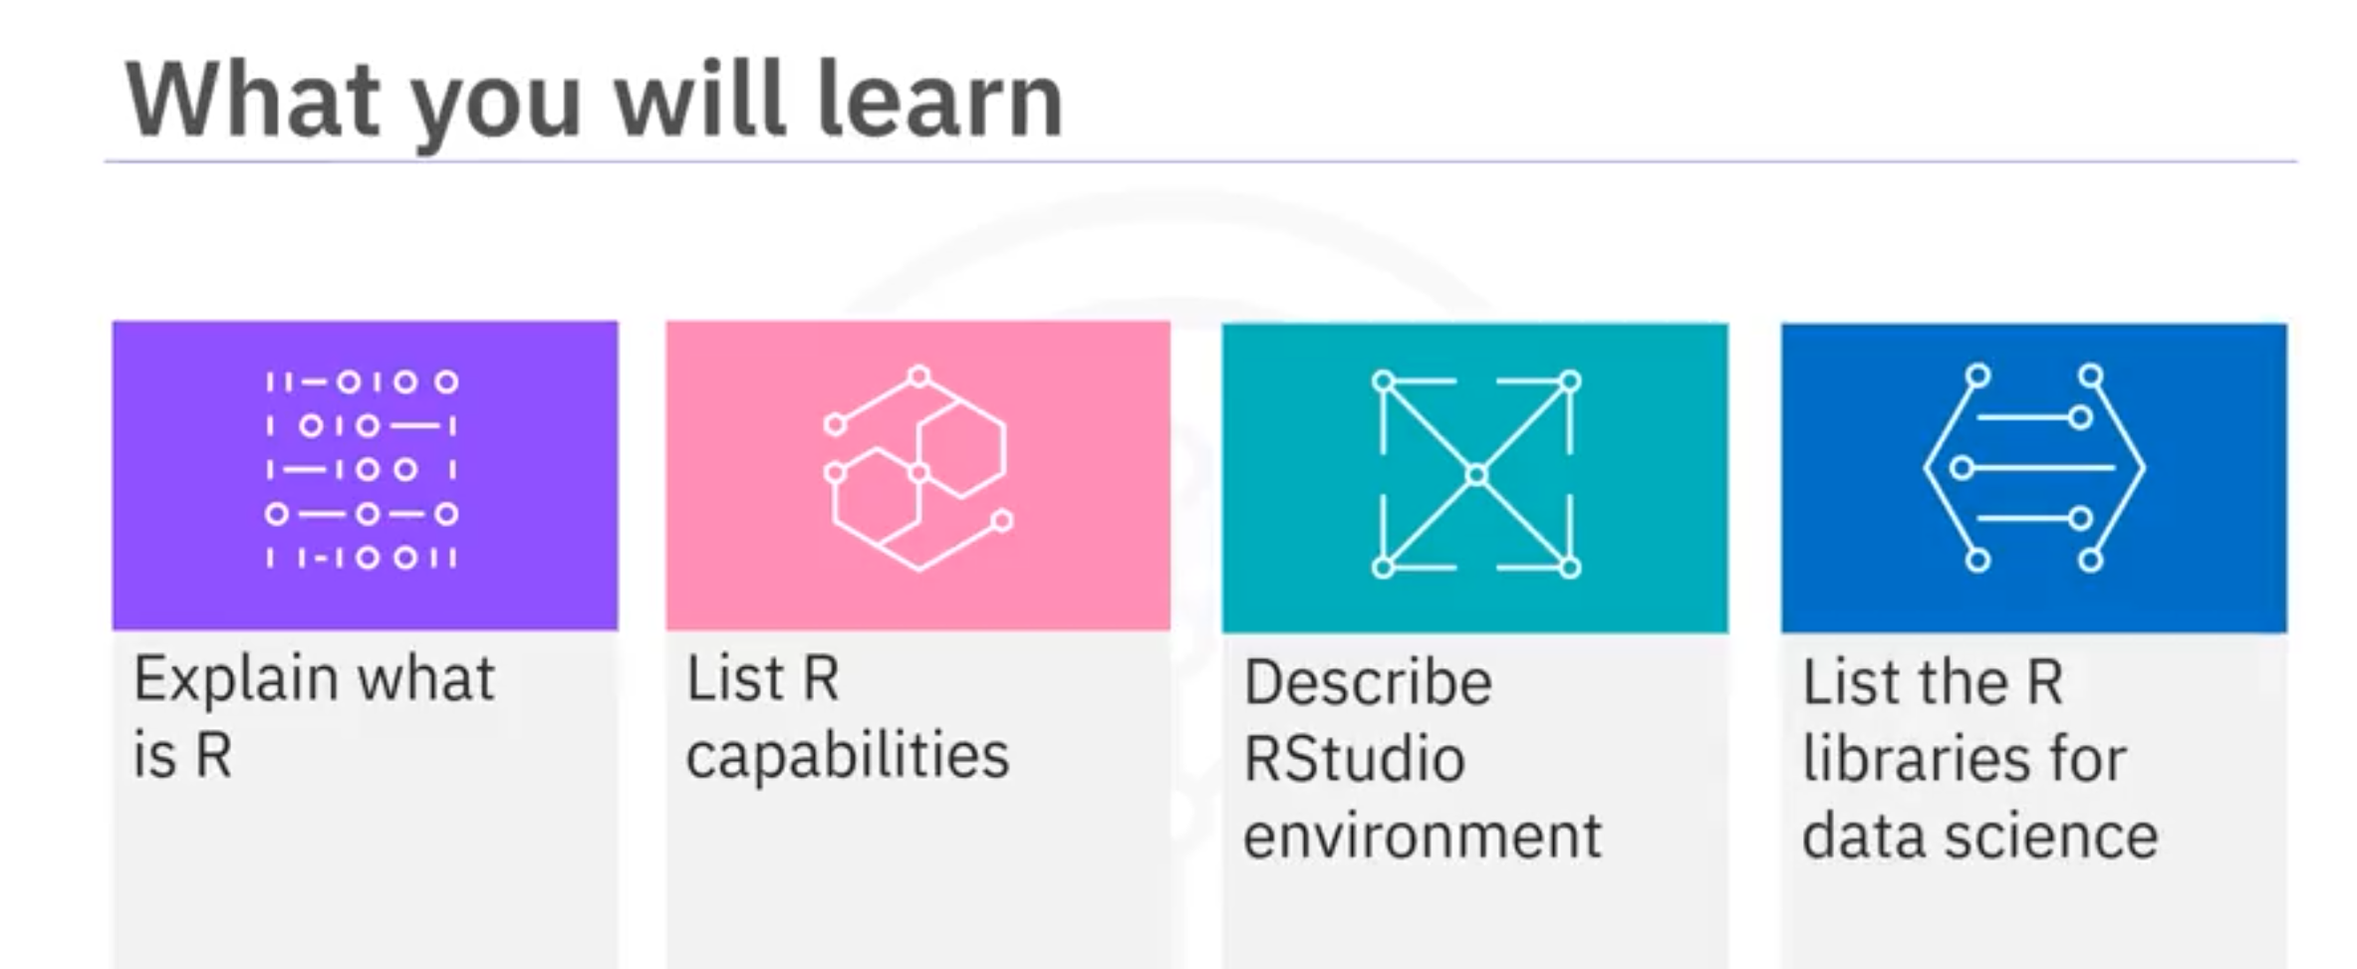

It is a powerful tool for data processing and manipulation, statistical inference, data analysis, and machine learning algorithm. Based on 2017 analysis, it was found that R is used most by academics, healthcare, and the government. R supports importing of data from different sources like flat files, databases, web, and statistical software such as SPSS and STATA.

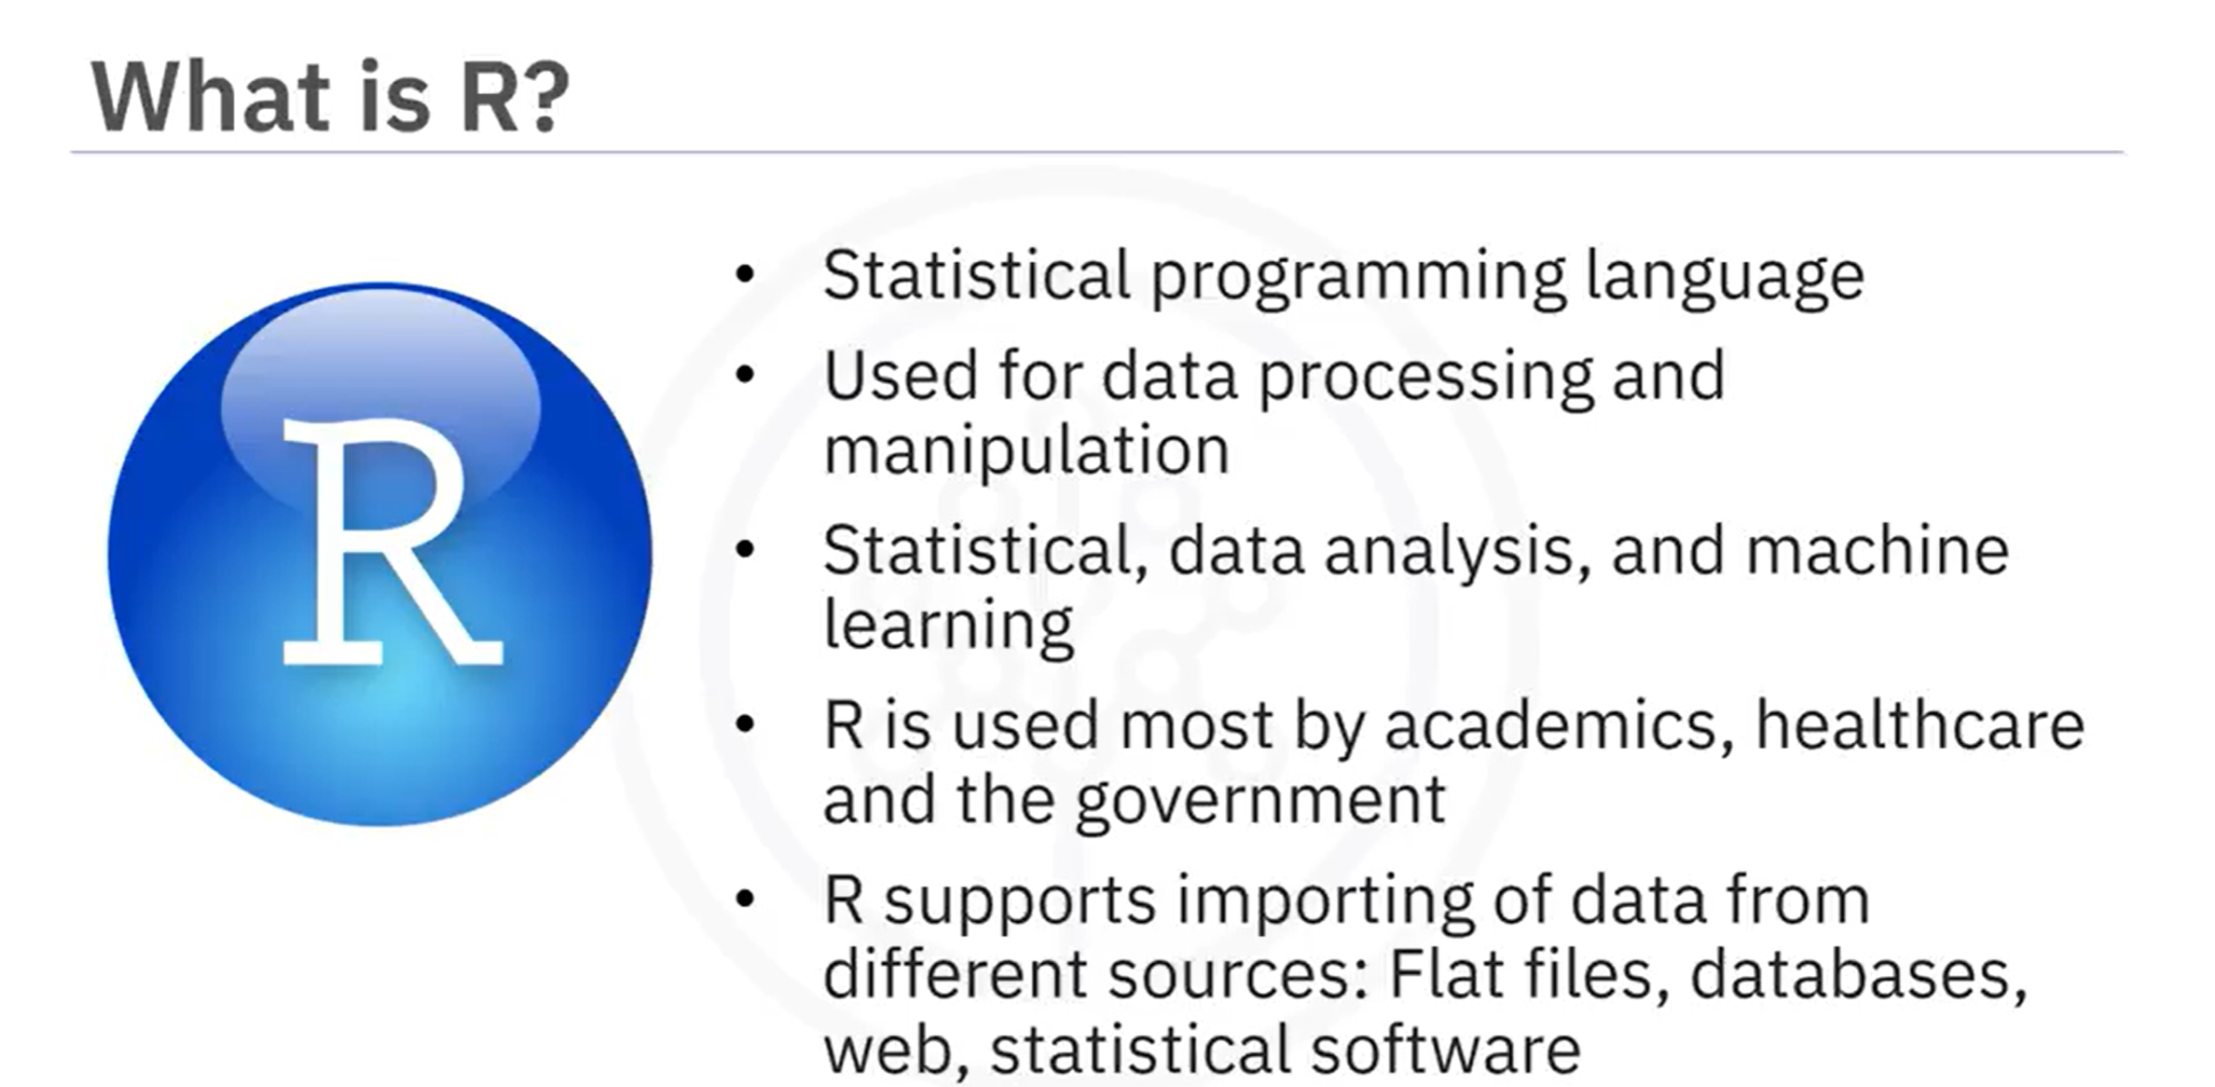

R is a preferred language for some data scientists because R functions are easy to use. It is also known for producing great visualizations and contains packages to handle data analysis without the need to install additional libraries

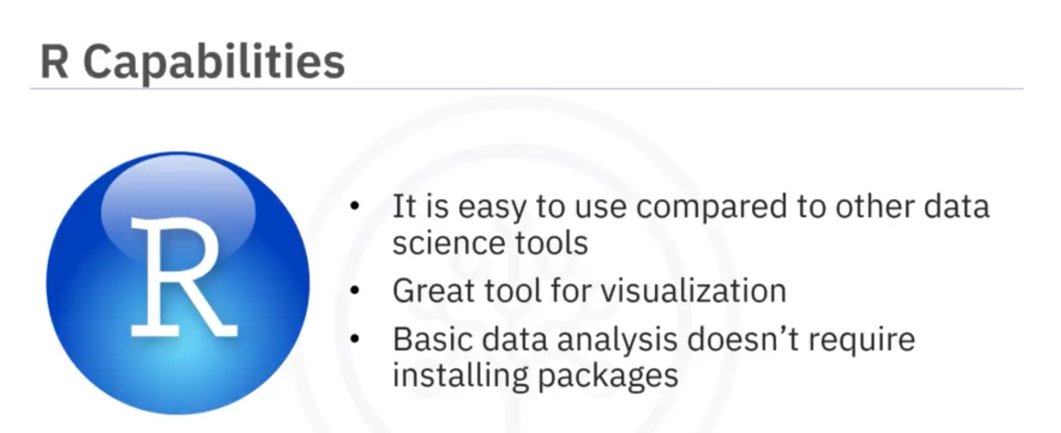

A popular integrated development environment for developing and running the R language source code and programs is RStudio. It improves and increases productivity with the R language.

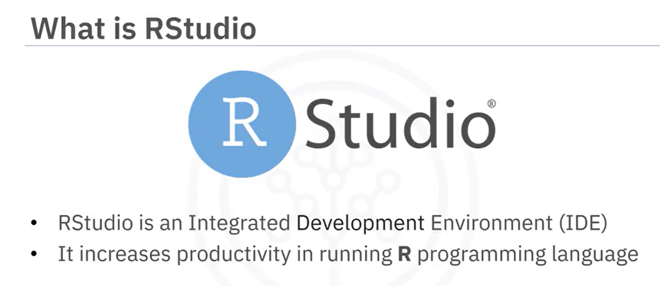

R studio includes: a syntax-highlighting editor that supports direct code execution and a place where you can keep a record of your work, a Console for typing R commands, a workspace and History tab that shows the list of R objects you created during your R session and the history of all previous commands, and finally, Files, Plots, Packages, and Help tabs

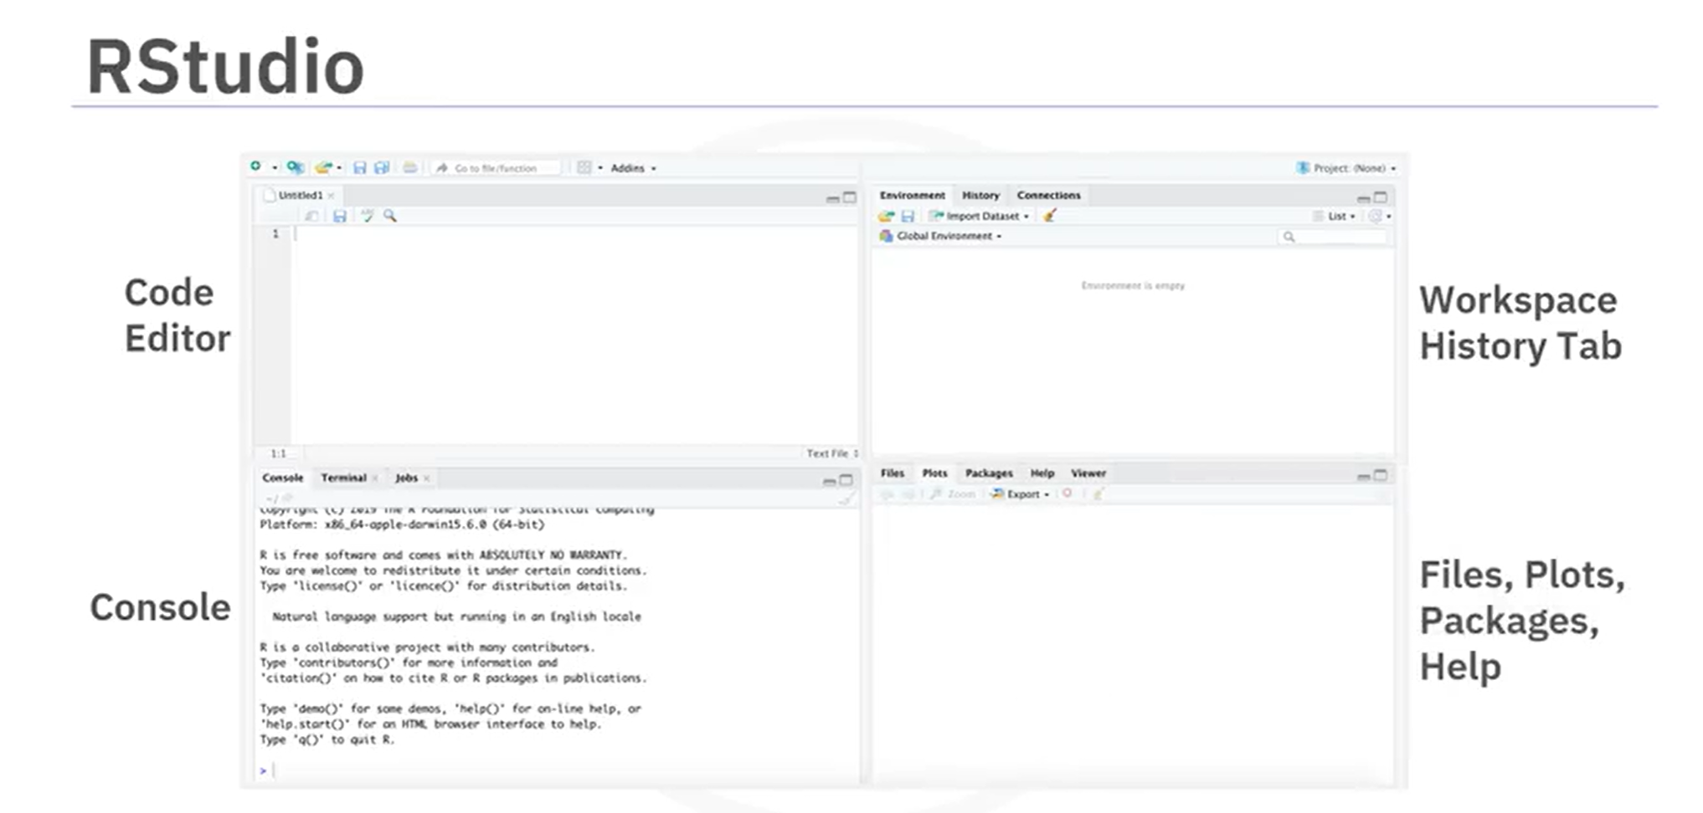

* The Files tab shows files in your working directory.
* The Plots tab displays the history of plots you have created. You can also export plots to PDF or image files.
* The Packages tab displays external R packages available on your local computer.
* And, the Help tab provides help on R resources, R studio support, packages, and many more.

If R is your tool choice for data science, here are some popular R libraries available in the Data Science community: dplyr for manipulating data, stringr for manipulating strings, ggplot for visualizing data, and caret for machine learning. To get you up and learning quickly, we have provided you with an R Studio virtual environment as part of the Skills Network Labs. This virtual lab environment is designed to assist you to easily practice what you learn in the course and skip the need to create an account or download or install anything.

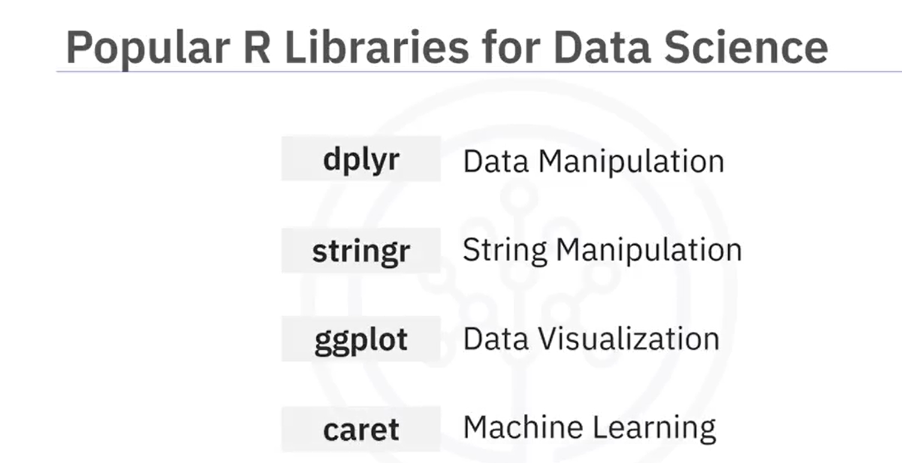

In this video, you learned the capabilities of R and its uses in Data Science, the RStudio interface for running R codes, and popular R packages for Data Science.

**Optional Reading: Download & Install R and RStudio**

**Hands-on Lab: Download & Install R and RStudio**

Estimated time needed: **15** minutes

Multiple programmers are moving towards data science, and in this process, R and RStudio play an essential role. So in this lab, you will understand how to install R and RStudio.

**Objectives**

* Download and Install R
* Download and Install RStudio

**Overview of R and RStudio**

There are several cloud based data science tools that make team collaboration accessible. At times it is useful to work directly on your desktop.

R is a command-line interface; there are several graphical front-ends available. RStudio is an integrated development environment (IDE) for R. It includes the environmental tab, which shows the generated variables. In the history tab, you can see the commands used since starting, and there are other tabs such as files, plots, packages, help, and viewer. It has binaries available for major platforms, including Windows, Linux, and MacOS. This lab includes instructions for downloading and installing R and RStudio on Windows. Mac OS users can download the appropriate .pkg file from <https://cran.r-project.org/bin/macosx/> and follow the instructions.

**Exercise 1: Download & Install R on Windows**

**Step 1**: The **latest version** of R can be downloaded by clicking the link.

Windows: <https://cran.r-project.org/bin/windows/base/>

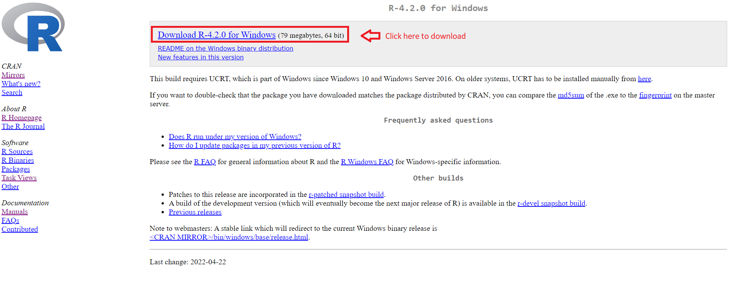

**Step 2**: Once the download completes, **right-click** the downloaded file, and click **Run as administrator**.

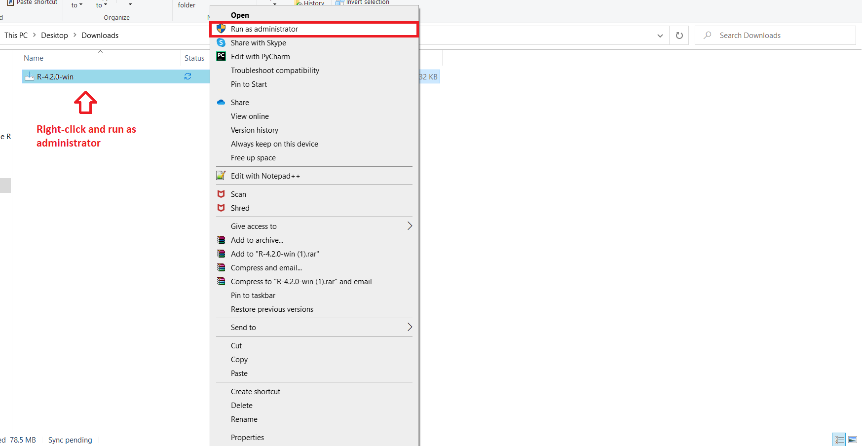

**Step 3**: Select your preferred installation **language**, and click **OK**.

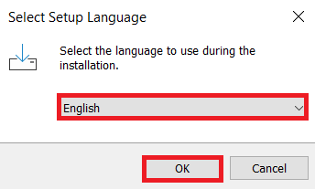

**Step 4**: Read and accept the license and click **Next**.

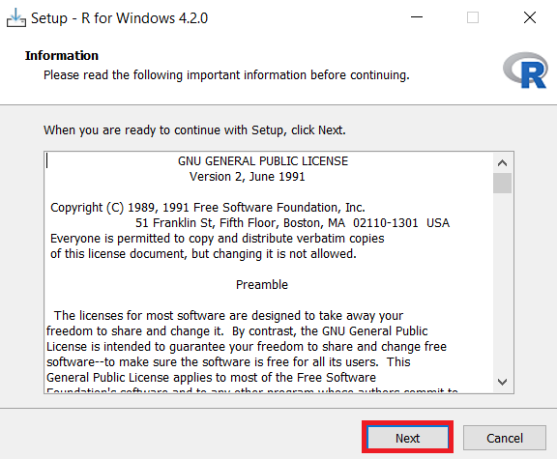

**Step 5**: Select the **Folder** where you would like to install R, or use the **Default** location, and click **Next**.

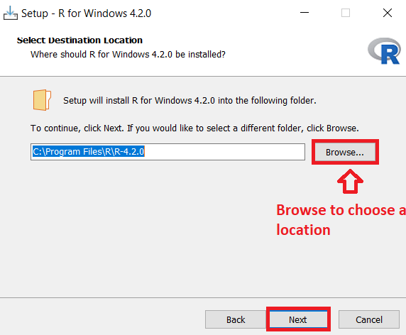

**Step 6**: Select the **Components** you want to install and click **Next**.

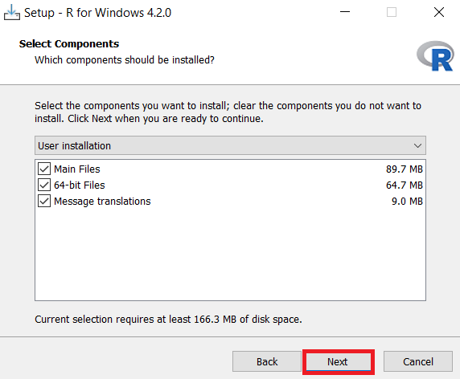

**Step 7**: In the **Startup options**, select the **Default** option and click **Next**.

**R Basics with RStudio**

After completing this lab, you will:

* Get familiar with RStudio
* Write your first R code snippet in RStudio

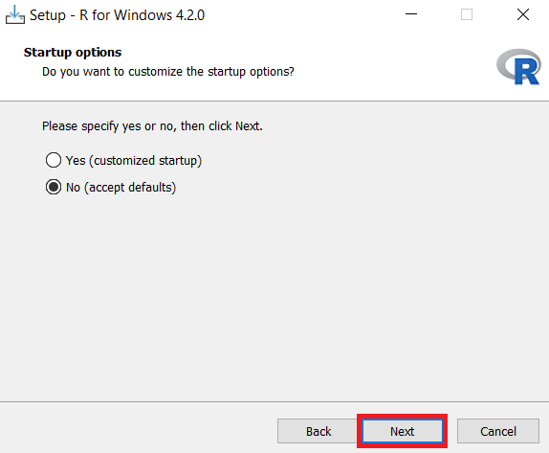

**Step 8**: In the **Select Additional Tasks** window, retain **Default** and click **Next**.

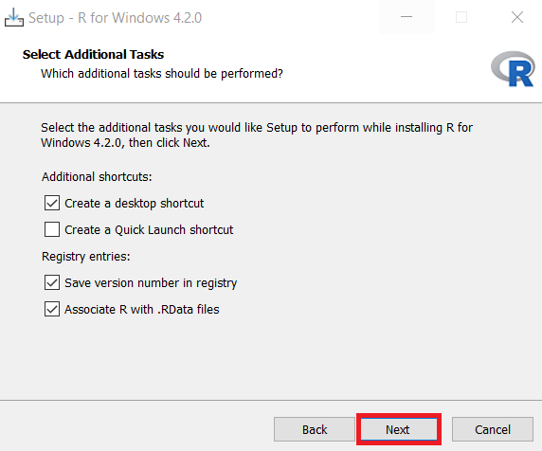

**Step 9**: Once installation is successful, click **Finish** to close the setup.

**Exercise 2: Download & Install RStudio**

**Step 1**: Use the link below to download **RStudio Desktop** on your local machine.

Link for Download RStudio for windows and mac: <https://posit.co/download/rstudio-desktop/>

**Step 2**: Click **Download RStudio desktop For Windows**, and your download will start.

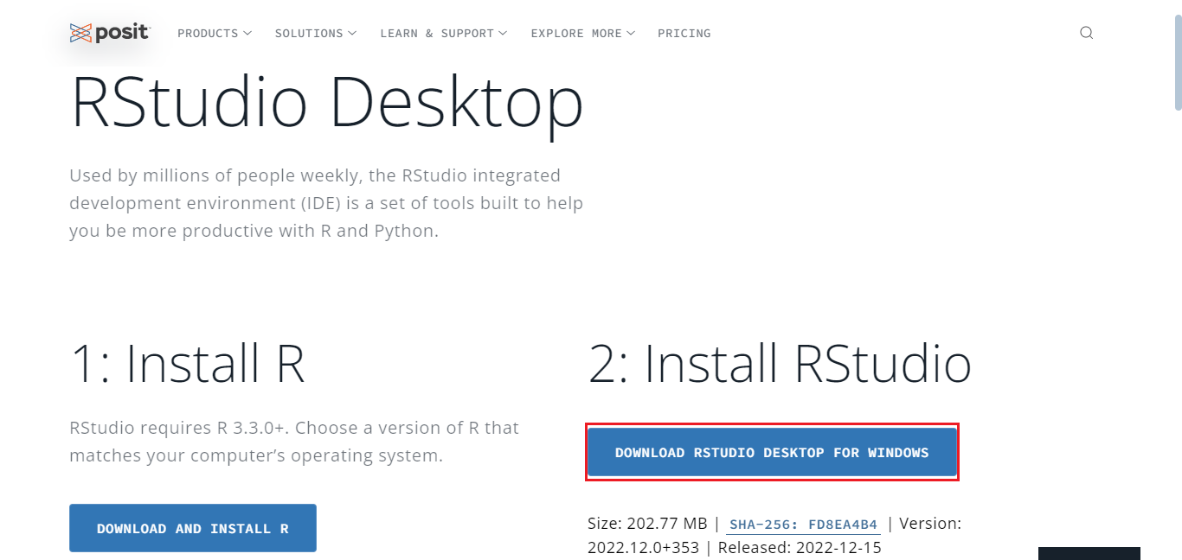

**Step 3**: Once the download completes, **right-click** the setup file, and click **Run as administrator**.

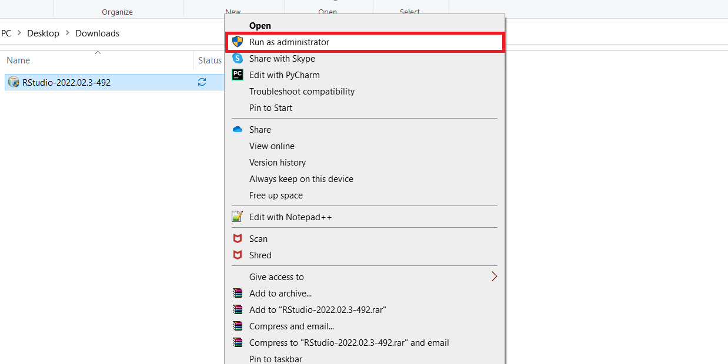

**Step 4**: In the RStudio setup window, click **Next**.

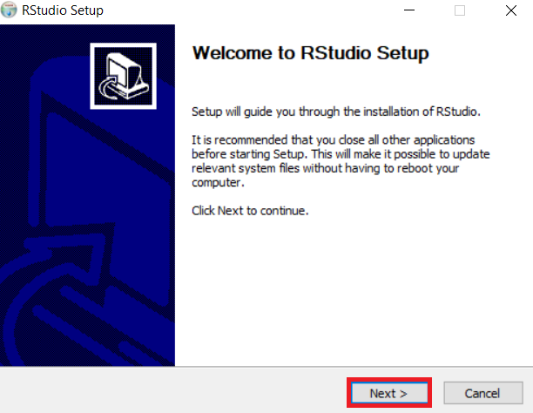

**Step 5**: Select the folder where you would like to install RStudio, or retain the **Default** installation location and click **Next**.

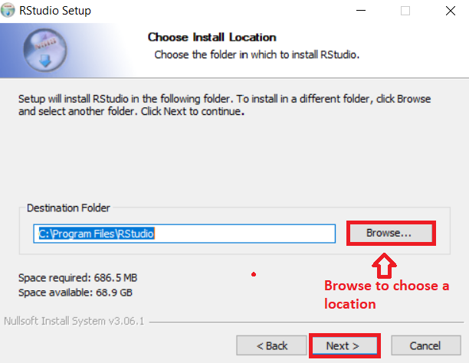

**Step 6**: In the Start menu window, click **Install** to install RStudio.

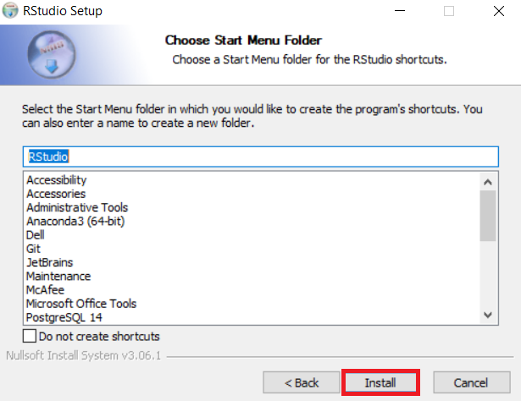

**Step 7**: Once installation completes, click **Finish** to close the window.

**Exercise 3: Execute R code in RStudio**

1. Open **RStudio** from the Windows start menu.

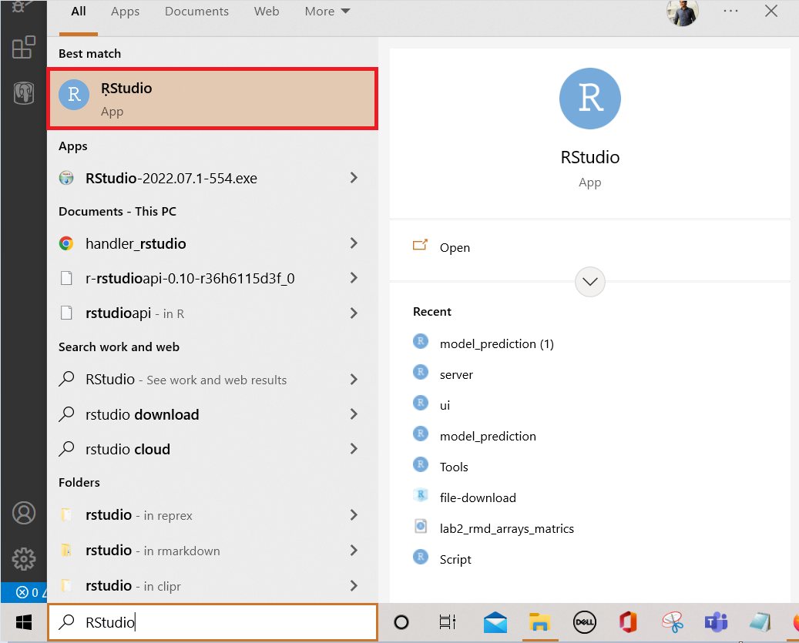

1. Click the **plus symbol** on the top left and select **R Script**.

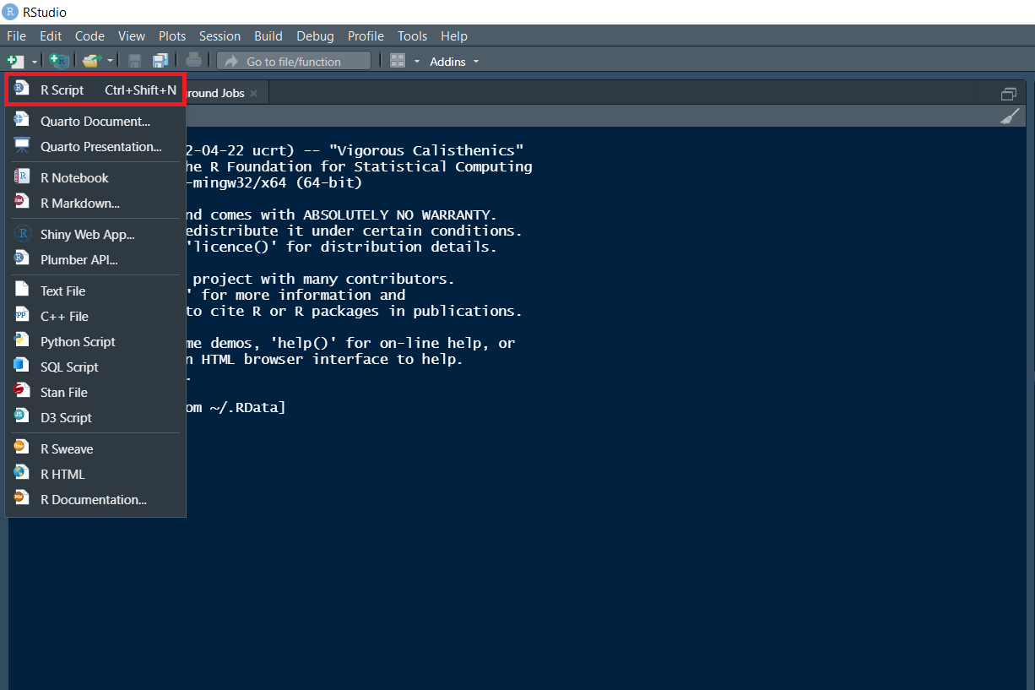

1. An **untitled** R Script panel opens. It would look as follows.

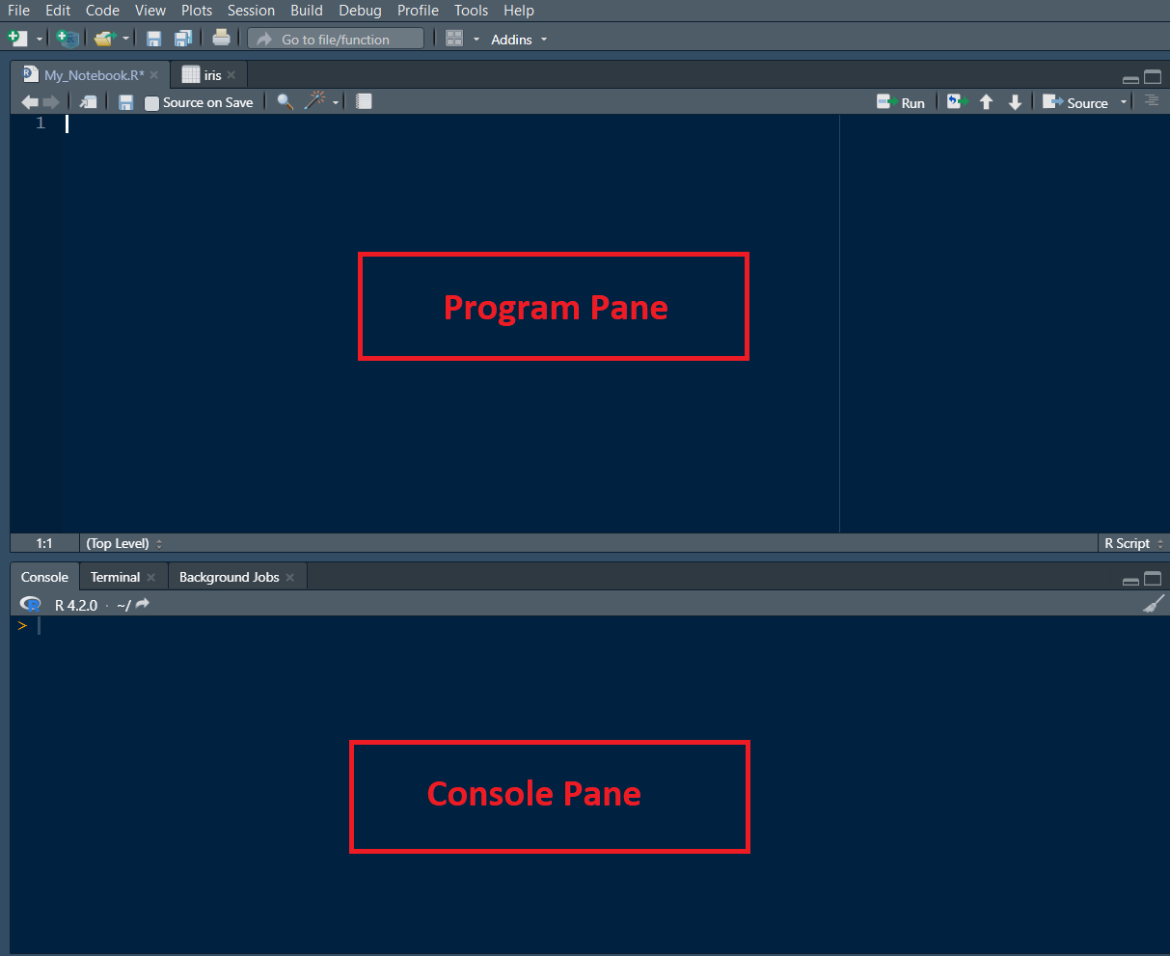

1. Now, load the **iris dataset**. Enter the following **lines** into the **Editor window** which appears. Next, select all of them. Then click the **Run icon** just above the Editor window.
2. 1
3. 2
4. 3
5. library (datasets)
6. data(iris)
7. View(iris)

Copied!Wrap Toggled!

Output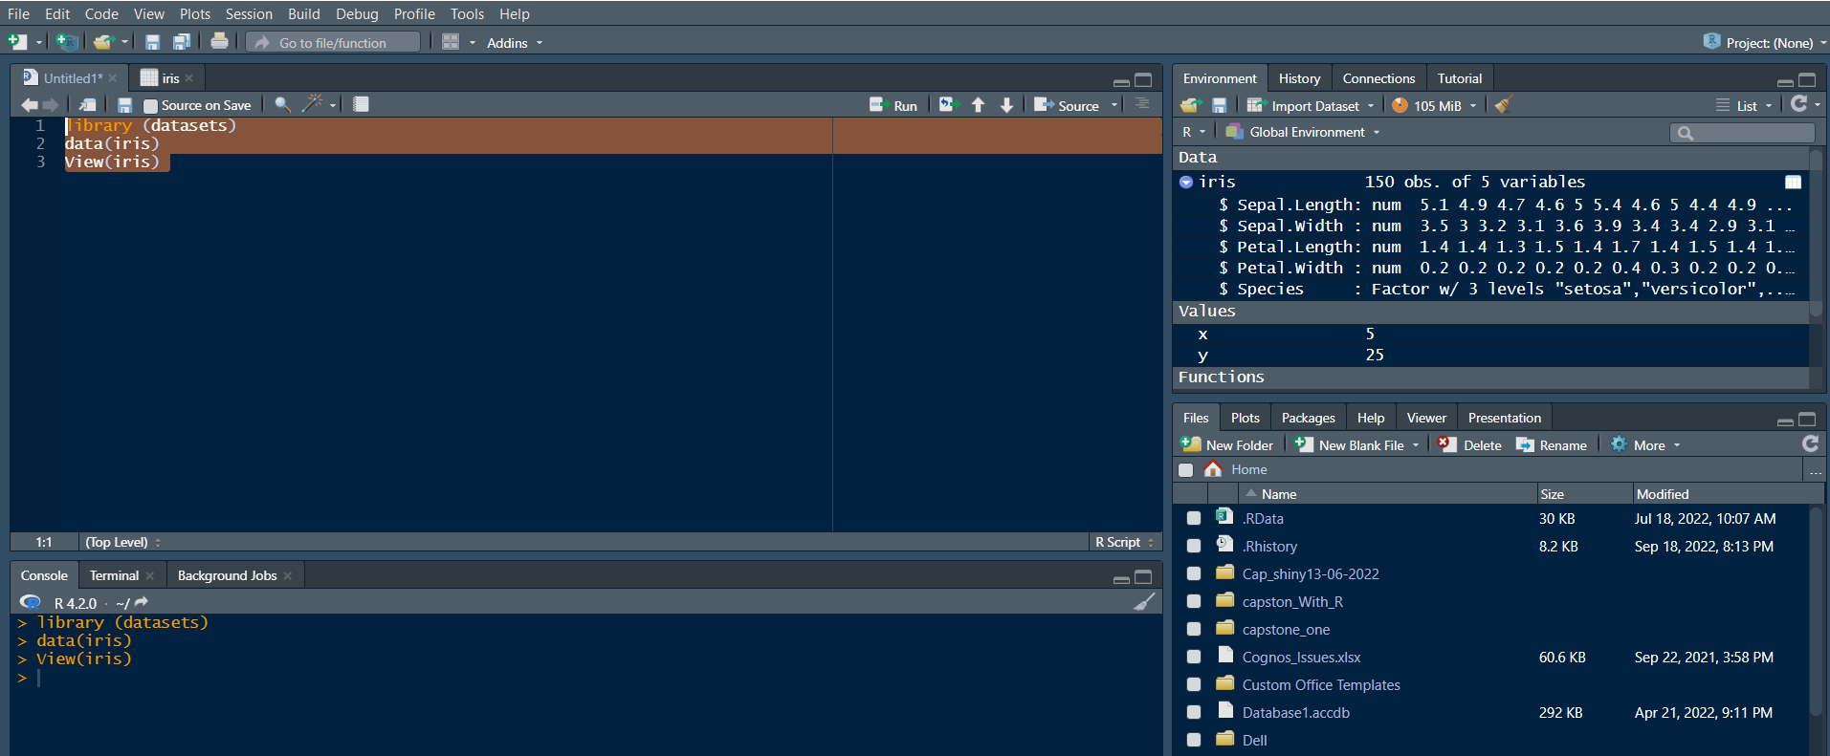

1. You are taken directly to the data view tab to inspect your dataset. You can see five columns in this dataset, the first four are floating point, and the last one is the label of the data type string, which contains the category value of your data set. You can see that there are total of 150 entries.

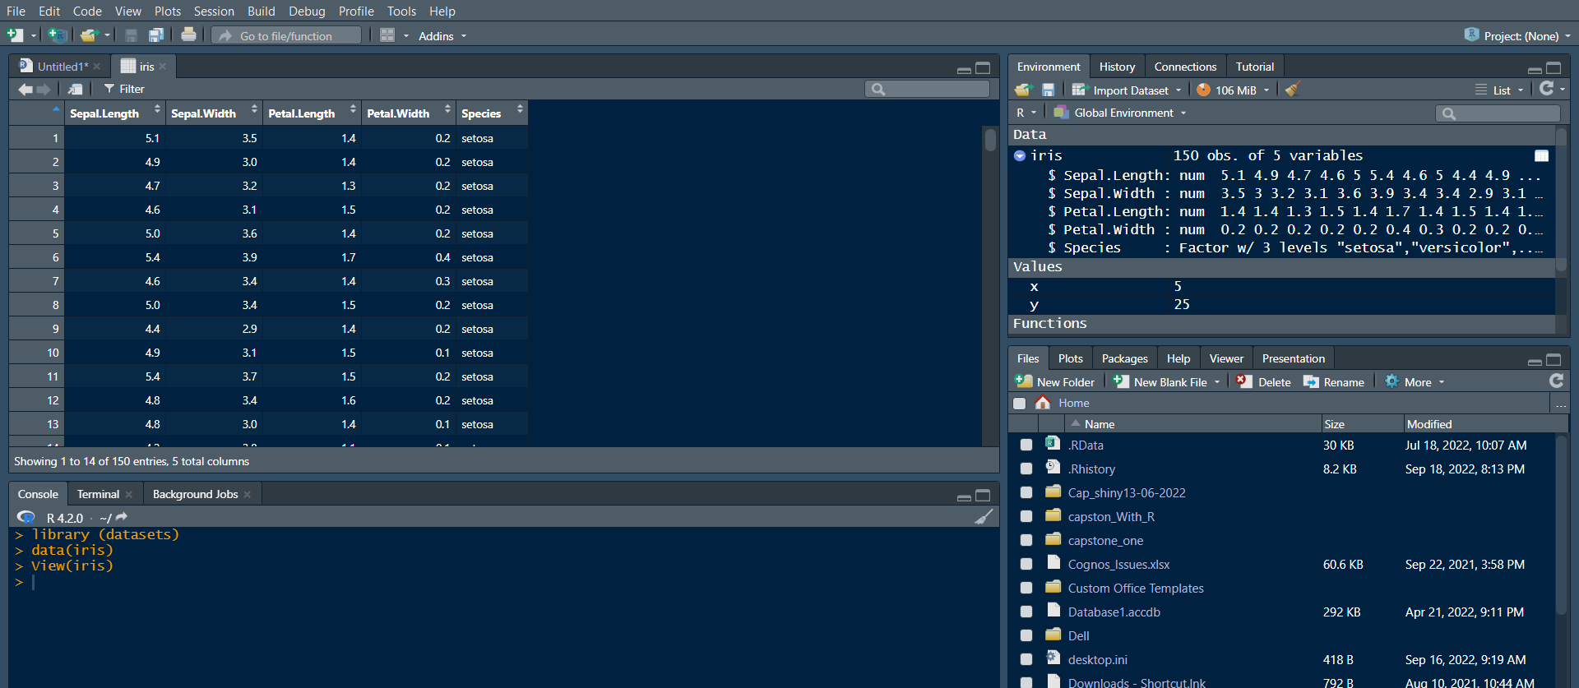

1. Now let's find how many **different species** are present in the data set. Type the following command in the **Editor window** and **click Run**.
2. 1
3. unique(iris$Species)

Copied!Wrap Toggled!

Output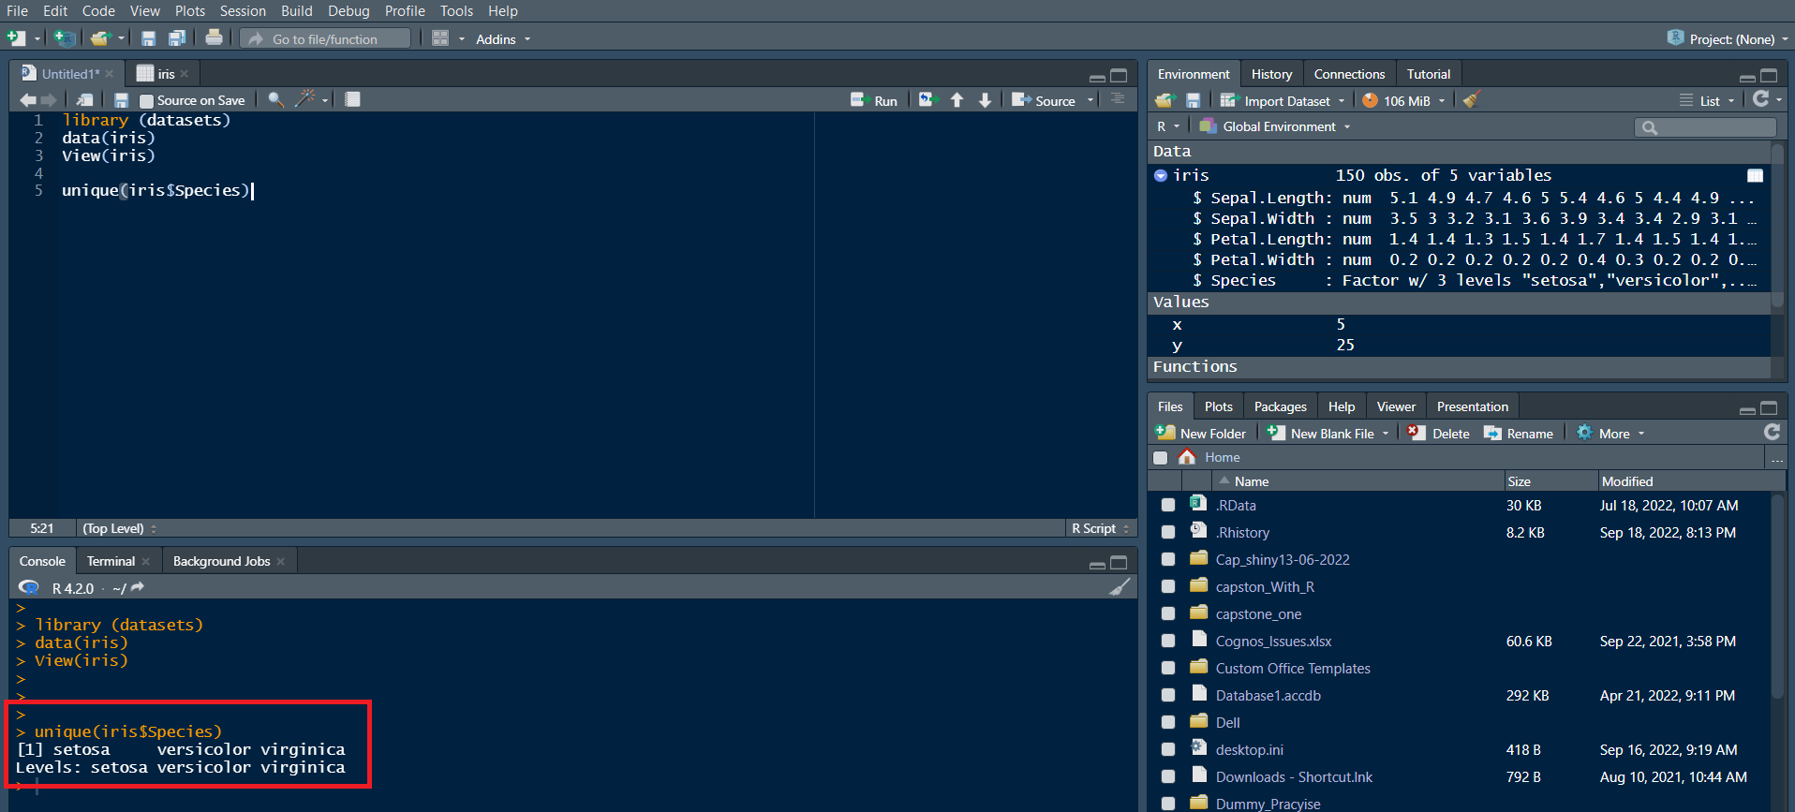

***Note****: In the Console window at the bottom, you will see the result of the executed command and know that only three different species are present in the dataset.*

1. **Save & provide a name to your Notebook**.

* To save the notebook, click **Save** or **Save as** in the **File** menu.

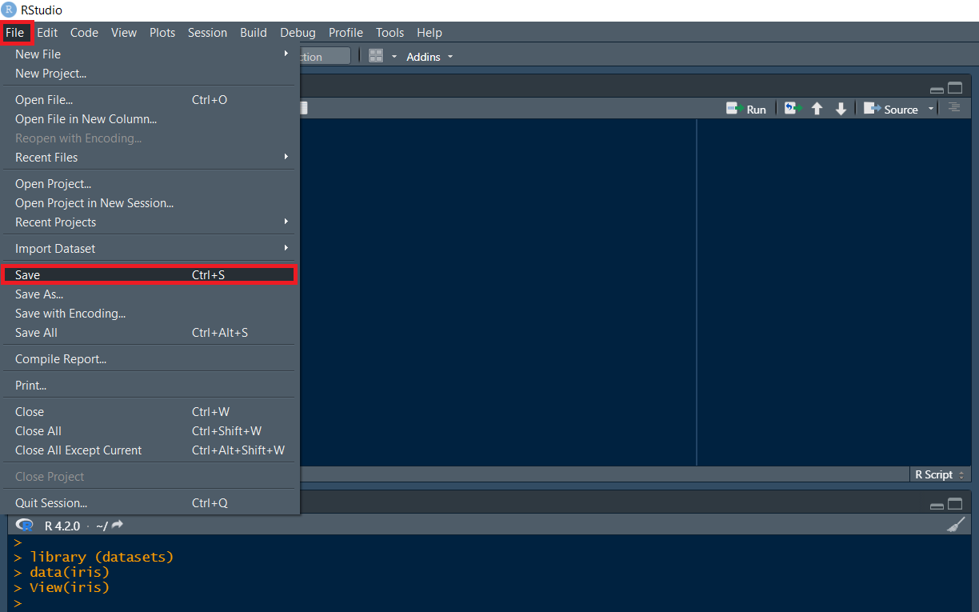

* Select the working folder to rename your notebook to ***My_Notebook***.

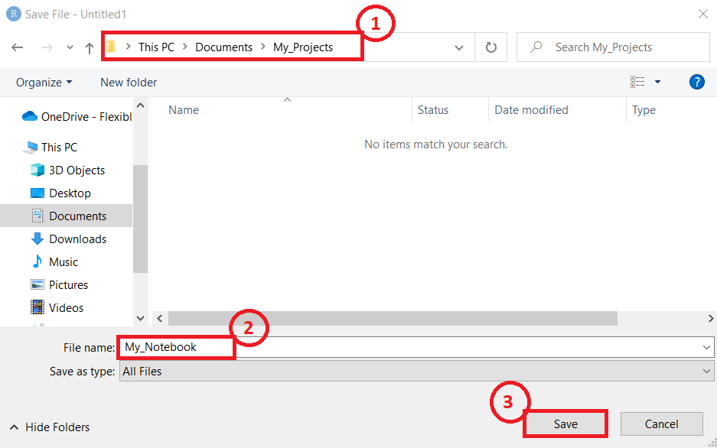 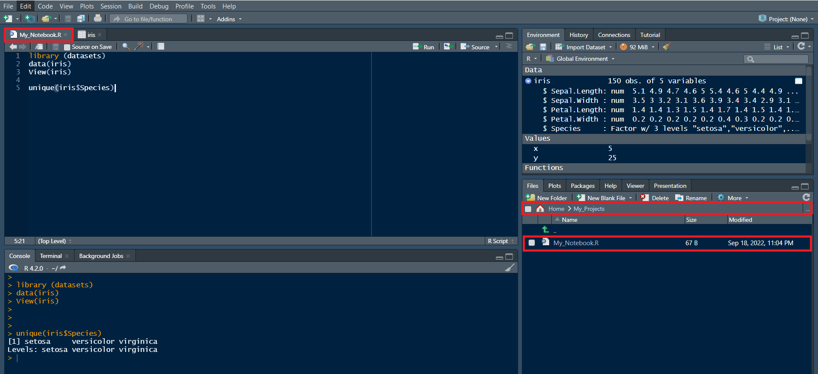

**Congratulations! In this document, you have learned how to download and install R and RStudio on your local machine. You also created a R notebook and saved it.**

**R Basics with RStudio**

After completing this lab, you will:

* Get familiar with RStudio
* Write your first R code snippet in RStudio

**RStudio main UI**

In this lab, you will be introduced to RStudio, the most popular and powerful IDE for developing R projects.

The main UI of RStudio is shown here:

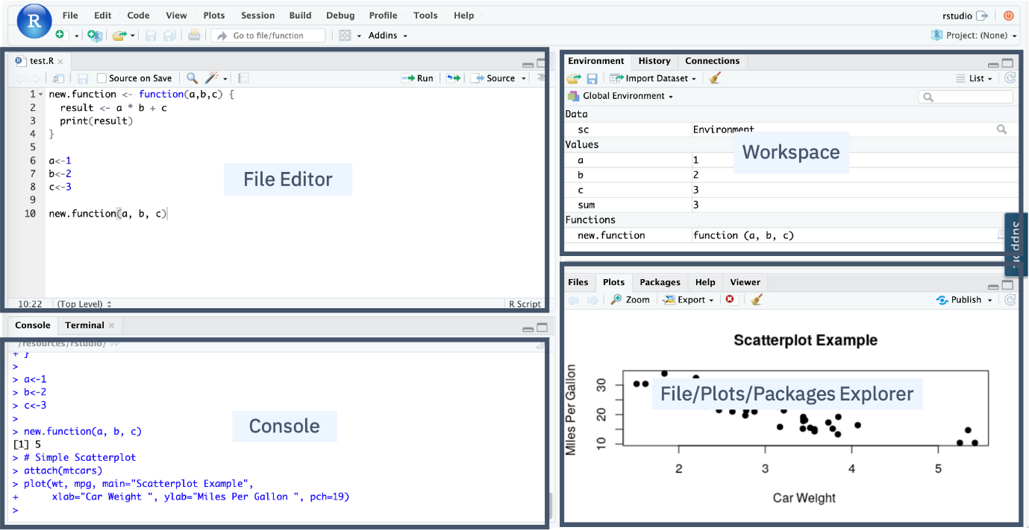

* In the Console panel, you can quickly try some R commands and see the results immediately.
* In the File Editor panel, you can write your R code or other text files with the help of syntax highlighting and auto completion.
* In the Workspace panel, you can review and manage the created objects.
* In the File/Plots/Package Explorer panel, you can manage your files and other assets, such as plots or packages.

**Write the first Hello World code snippet in the Console**

Let us write your first **Hello World** in RStudio Console.

* Find the blinking cursor in the Console panel, type an incomplete prin or print and pause a little bit for RStudio to show a pop-up suggestion list:

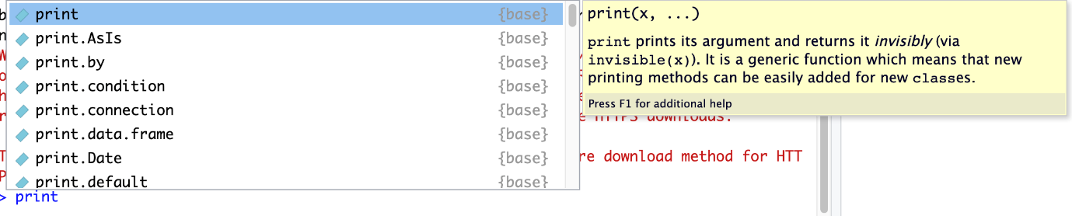

The auto-complete feature of RStudio can help avoid the need for memorizing the code details and reducing keystrokes by just selecting from a suggestion list.

* Select the print function and add a character input Hello World!, then press the Enter key:

1. 1
2. print("Hello World!")

Copied!Wrap Toggled!

You should see Hello World! printed on the console.

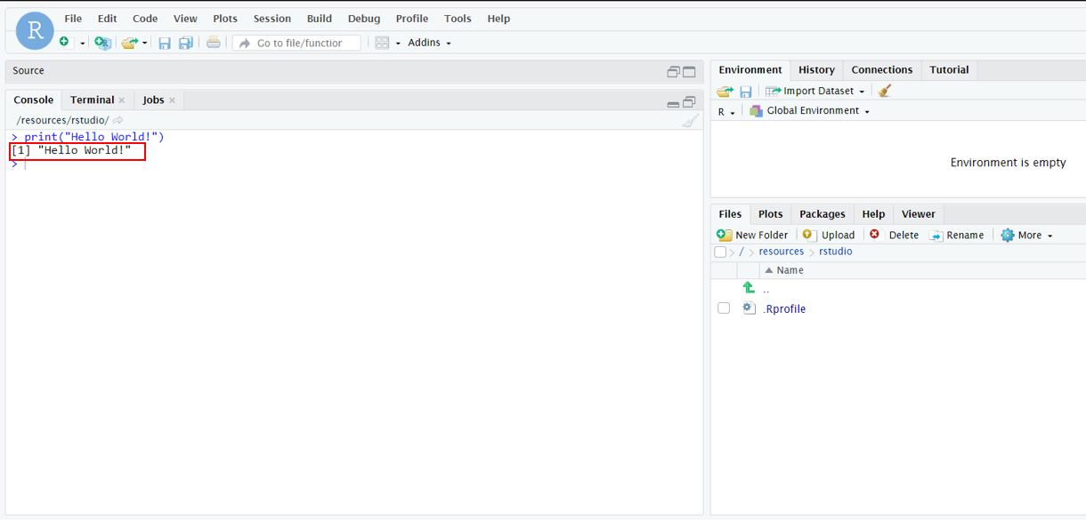

That’s it, you have written your first Hello World code snippet in RStudio.

For practice, you can play with the console by typing anything you have learned so far, such as creating variables and doing basic math operations.

If you want to clear the console, you can press Ctrl or Control + L key combination.

**Review R objects in the Environment panel**

Now let’s try the Environment panel to review the R objects we created in the console.

* Type and run the following three lines of code in the console:

1. 1
2. x<-1

Copied!Wrap Toggled!

1. 1
2. y<-2

Copied!Wrap Toggled!

1. 1
2. z<-x+y

Copied!Wrap Toggled!

You should see three variables x, y, z with assigned values in the Environment panel.  
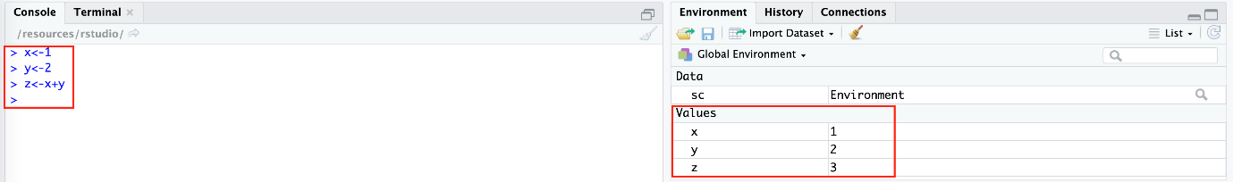

* To clean the workspace, you can click the Broom icon as shown below:

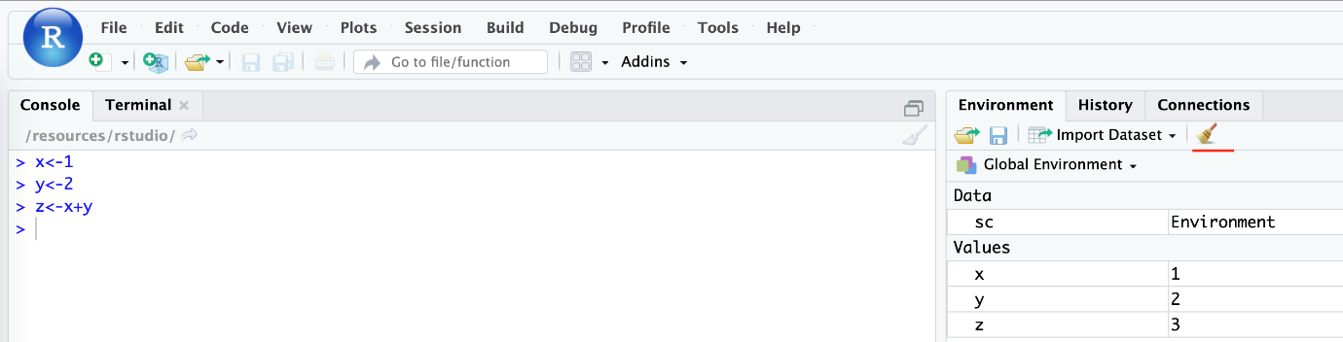

**Create your first R script file**

By now, you have written some simple R code in the console interactively. Next, create an R script file with multiple lines of code and run them in batch mode.

* First, from the menu click File > New File > R Script.

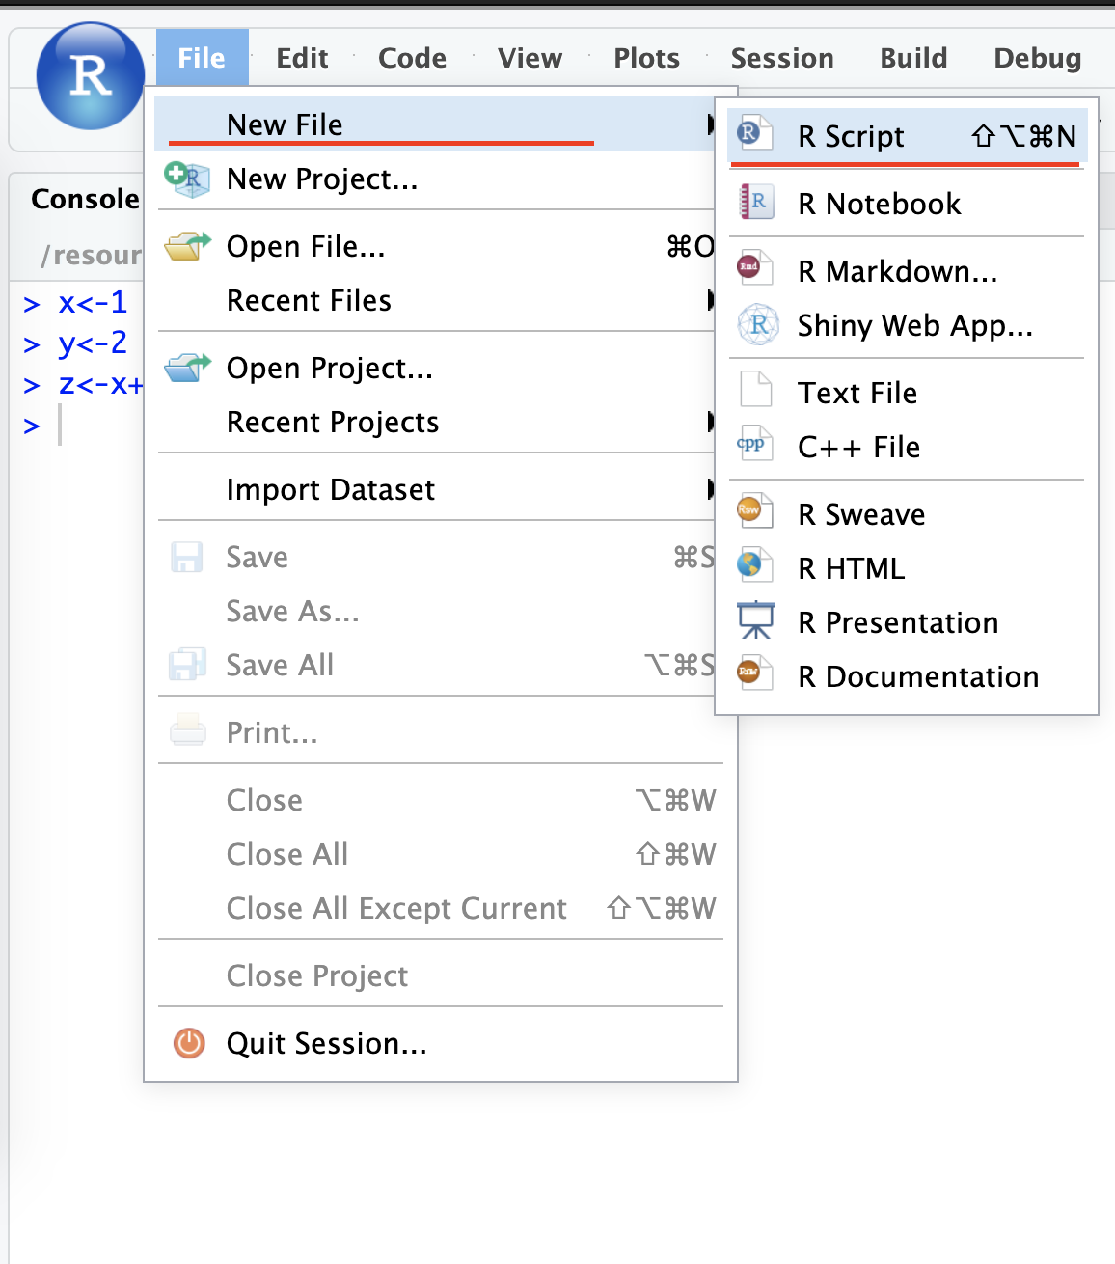

* Then click File > Save, and name the file something like first_script. After the script file is saved, you can see an empty file called first_script.R file created in your working directory.

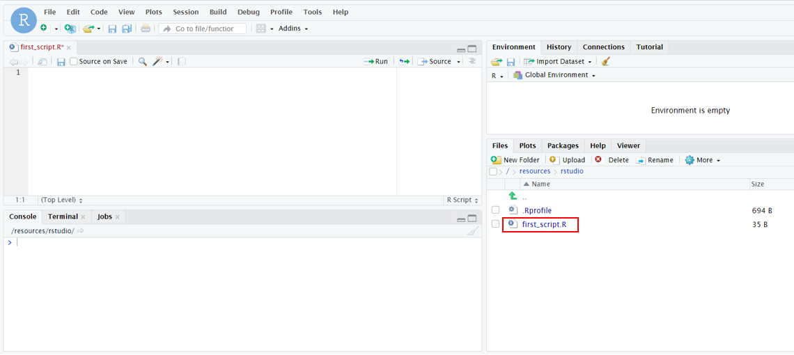

* Next, click first_script.R file to add the following code snippet:

1. 1
2. 2
3. 3
4. 4
5. x <- 3
6. y <- 4
7. z <- x + y
8. print(z)

Copied!Wrap Toggled!

You need to make sure the last line of the file is a new empty line.

So after copying the code snippet above, press the Enter key to start a new line in the script file.

Now, you can run the code in the script file, there are two running modes:

* The first mode is called Run the current line or selection. You can click and drag your mouse or use Shift + Up/Down keys to select all lines and then click the following Run icon to run them:

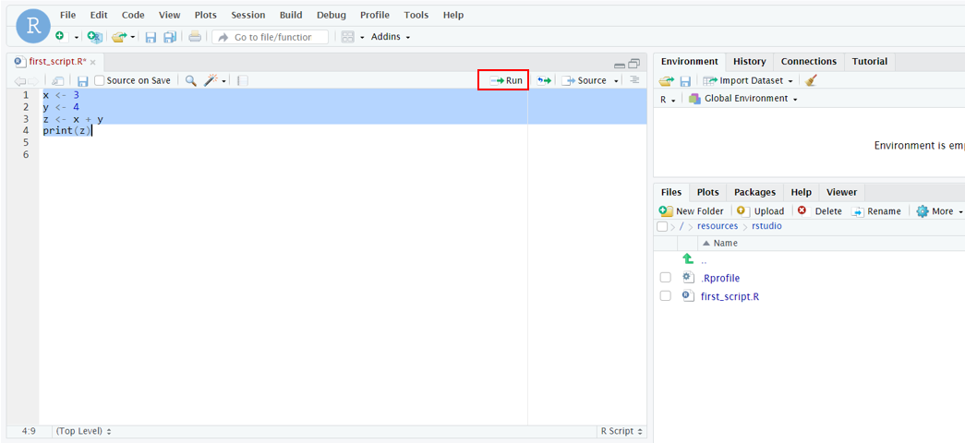

* The second mode is called Source where it runs all lines of code in the file by clicking the following Source icon:

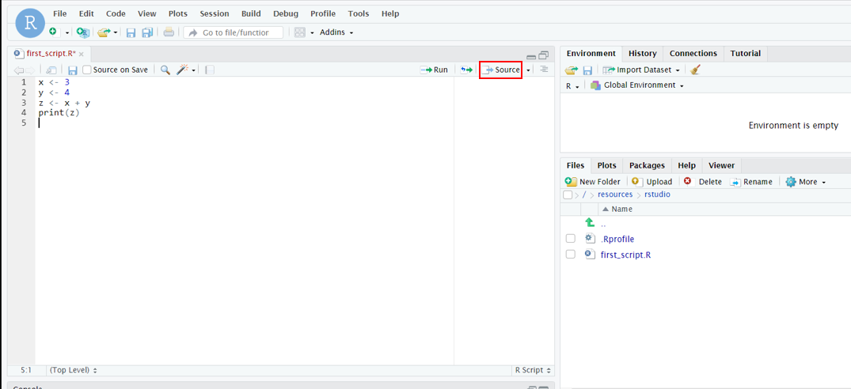

You should see the results in the console:

1. 1
2. 2
3. source('/resources/rstudio/first_script.R')
4. [1] 7

Copied!Wrap Toggled!

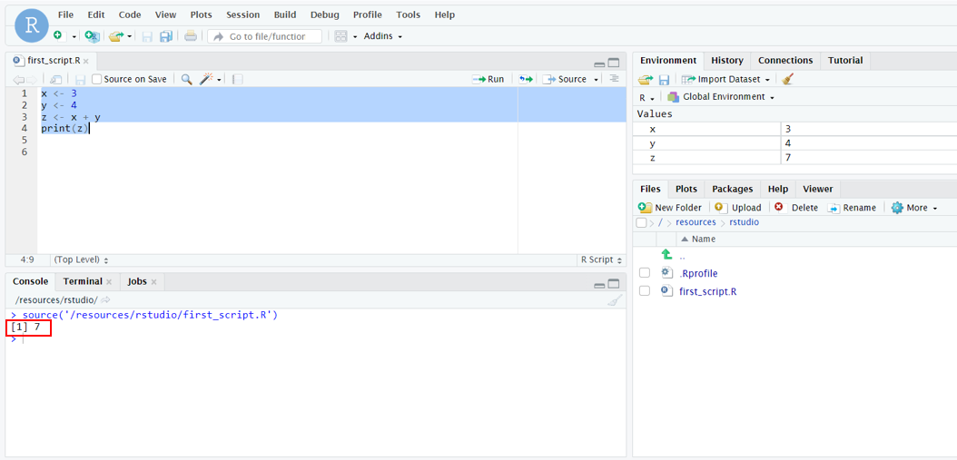

That’s it about creating and running the R script file!

**Exercise: Practice Tasks**

**Task 1:** Create a new R script

* Assign two variables where x = 10 and y = 20.
* Save the file as **Subtract.R**.

Click here for solution

1. 1
2. 2
3. x <- 10
4. y <- 20

Copied!Wrap Toggled!

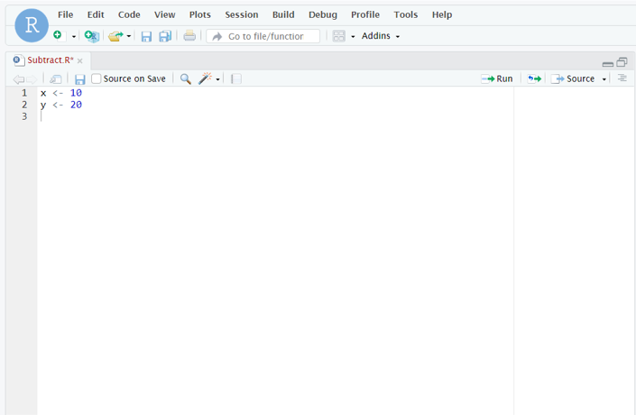

**Task 2:** Subtract x from y. Store in variable result and print the output.

Click here for solution

1. 1
2. 2
3. 3
4. 4
5. x <- 10
6. y <- 20
7. result <- y - x
8. print(result)

Copied!Wrap Toggled!

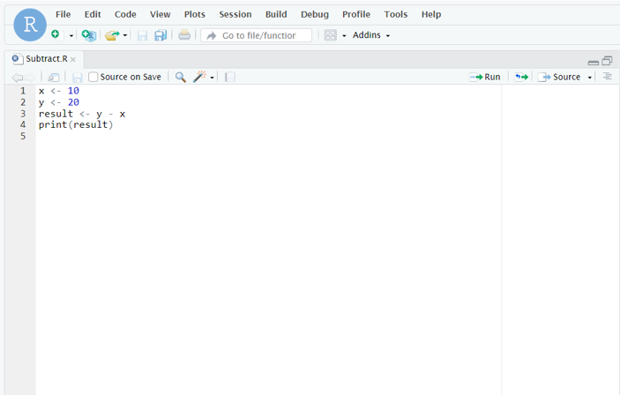

**Plotting in RStudio**

Welcome to “Plotting in RStudio.” After watching this video, you will be able to: List the R data visualization packages, Use the inbuilt R plot function, Use the R ggplot library to add functions and arguments to the plot, And, add titles and names to the plot.

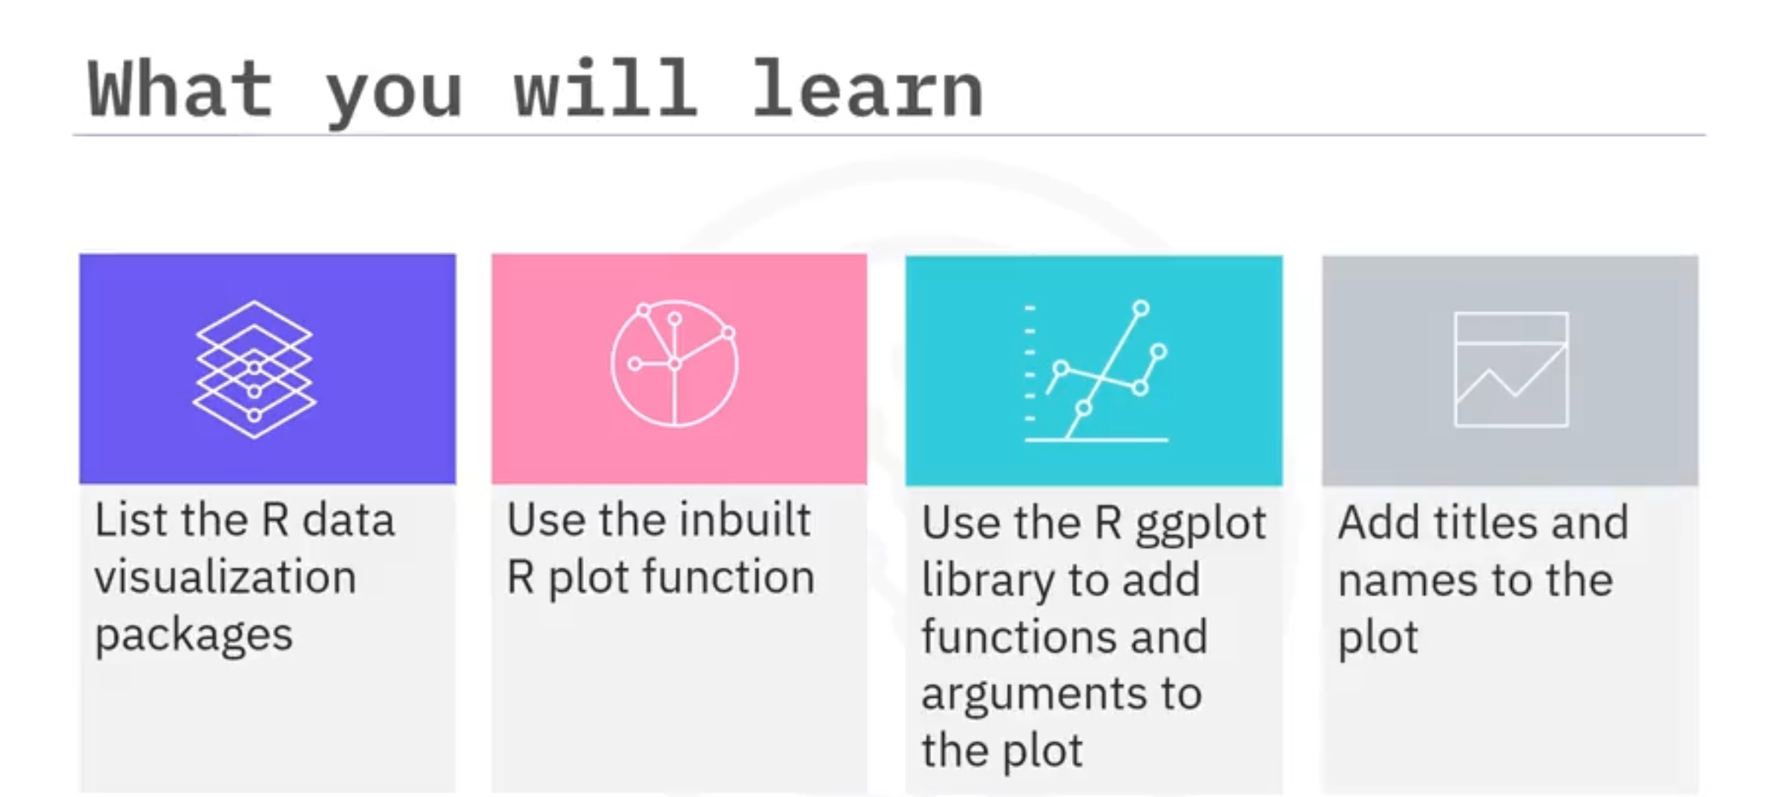

With the influx of data, one of your many jobs as data scientists is to produce insights using visualizations. R has different packages for data visualization that you can use based on your requirement. To install these packages in your R environment, use the install.packages and the package name command. Examples of R packages include the following. ggplot is used for data visualizations such as histograms, bar charts, scatterplots, and so on. It allows adding layers and components to a single visualization. Plotly is used for web-based data visualizations that can be displayed or saved as individual HTML files. Lattice is used to implement complex, multi-variable data sets. It is a high-level data visualization library that can handle graphics without customizations. And, Leaflet is used for creating interactive plots.

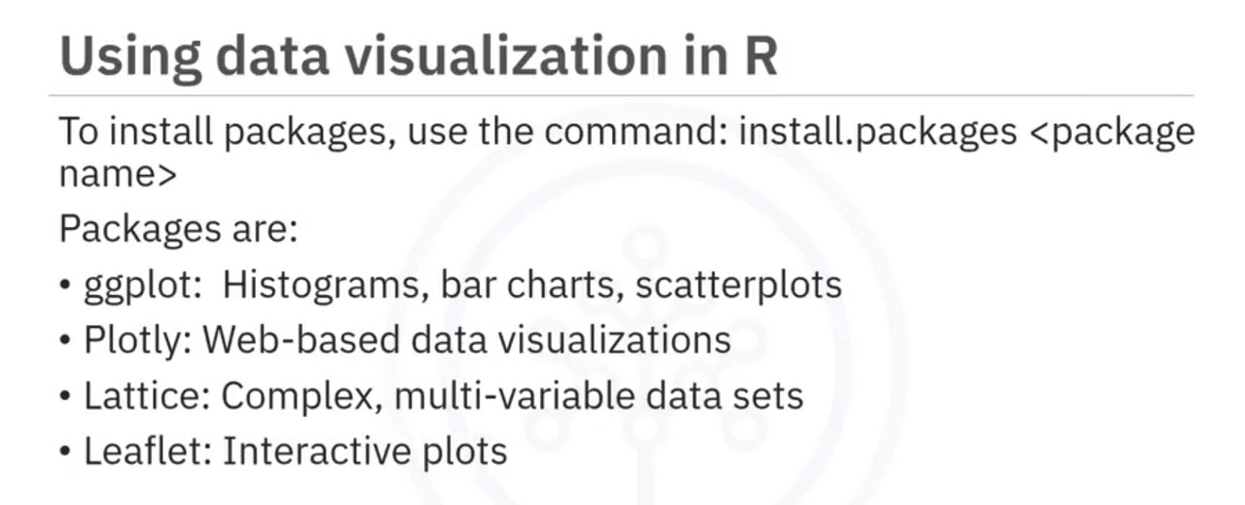

R has inbuilt functions to create plots and visualization. For example, you can create a plot using the definition shown here. The plot function returns a scatterplot of the values vs. the index.

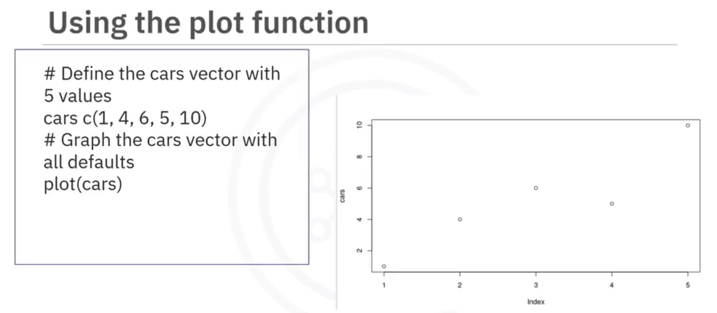

You can also add lines to the function and a title to make the visualization easier to read and understand. To add a line, you specify the type and to add a title, you select the title function. In the plot, you have added a line and a title.

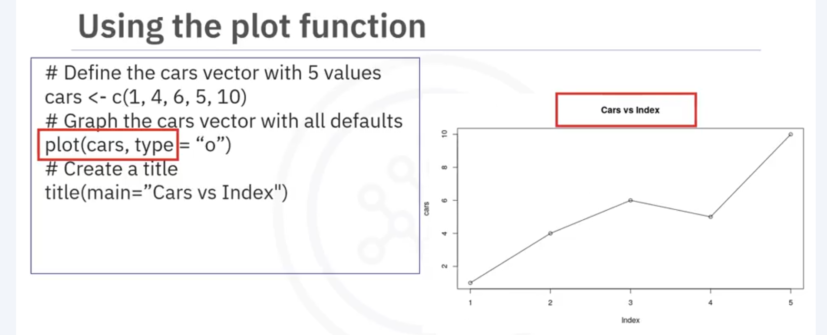

You can create informative visualizations using the ggplot library of R. It can handle complex requests by adding layers to plots using different functions and arguments. For example, to create a scatter plot, let’s use the inbuilt dataset Mtcars. You will first read the ggplot library into the memory using the library function. Next, use the ggplot function on the data frame MTcars, specify the X axis as miles per gallon and the Y axis as weight. Then add the geom point function to specify a scatter plot; otherwise, it will return an empty plot. The output will be an easier-to-read plot.

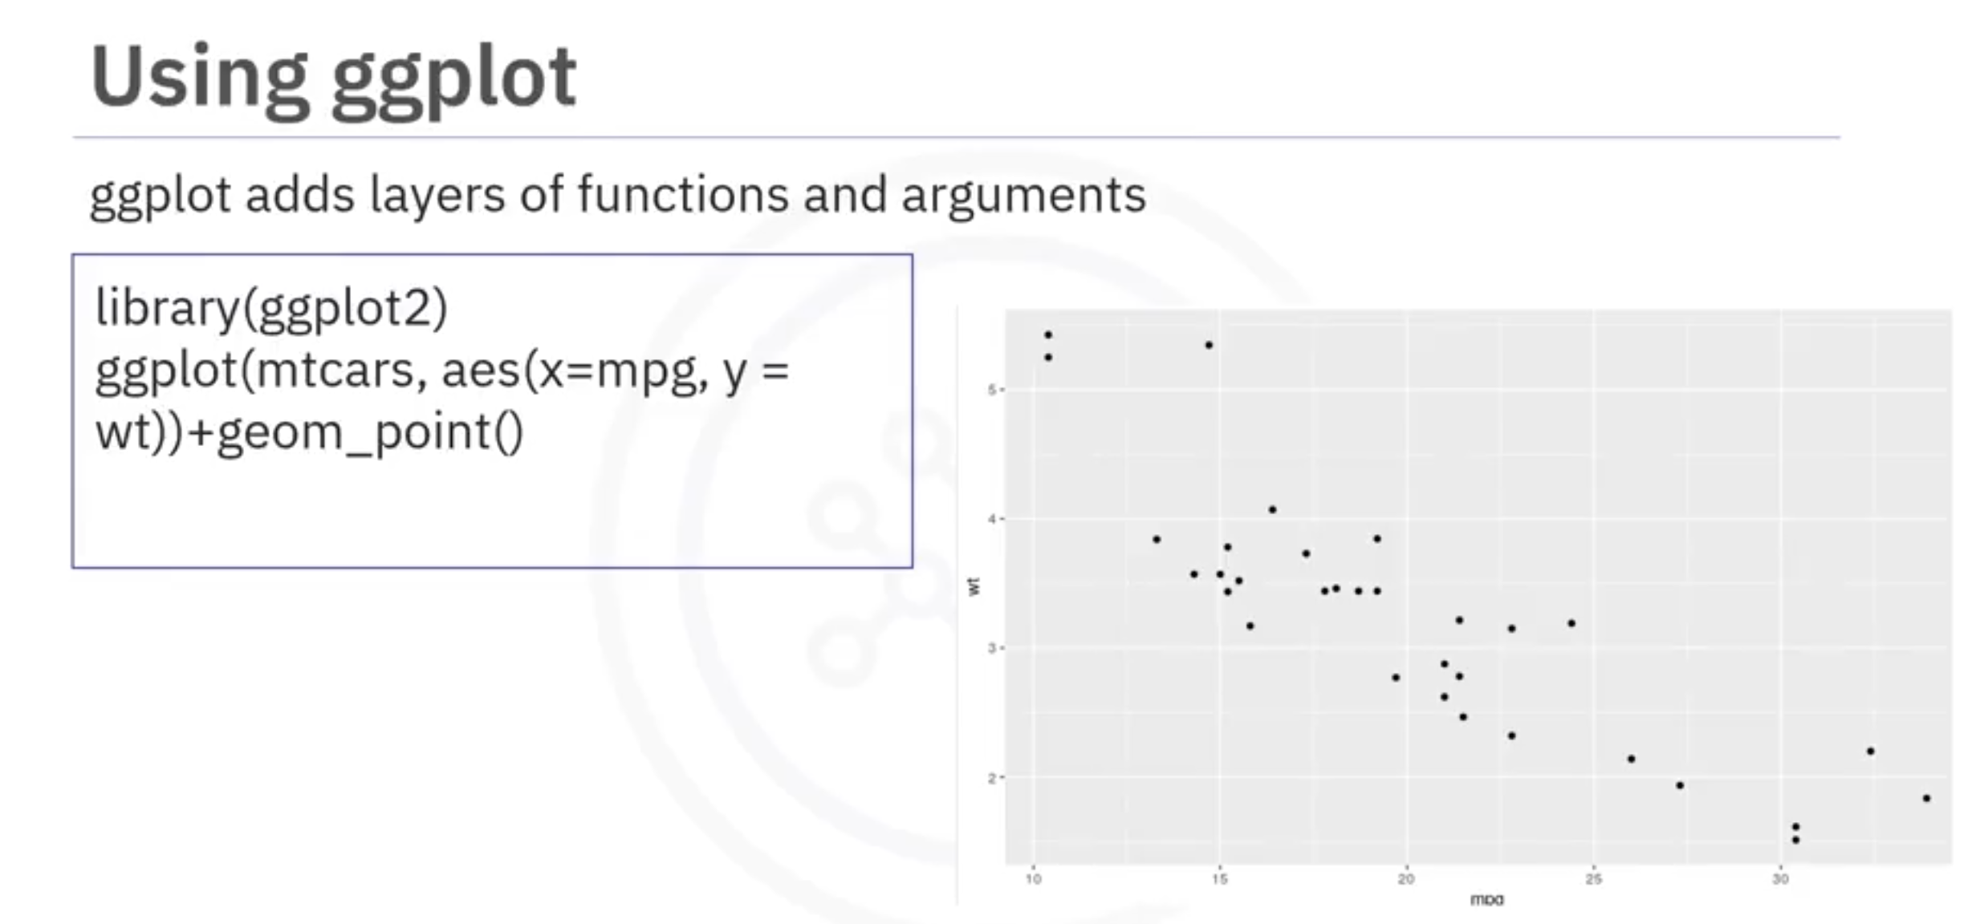

In addition, you can add titles and change the axis name by using the Ggtitle argument and the lab’s argument to specify appropriate names for both axes. The result will be a graph with meaningful titles. In the lab, you will recreate the graphics with ggplot and the extension library called GGally. GGally extends ggplot by adding several functions to reduce the complexity of combining geometric objects with transformed data.

In this video, you learned about: Popular data visualization packages in R, Plotting with the inbuilt R plot function, Plotting with ggplot, Adding titles and changing the axis names using the ggtitle and lab’s function.

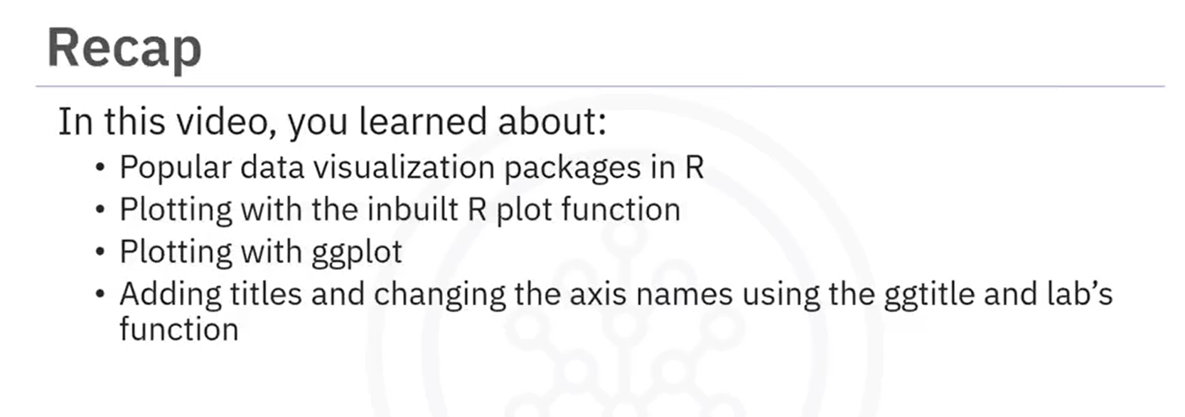

**Getting started with RStudio and Installing packages**

In this lab, you will learn how to get started with RStudio and install packages.



**Getting started with RStudio and Installing packages**

**Objectives of Exercise:**

After completing this lab, you will be able to:

* Load the datasets
* Install libraries

**Step 1** - Click the plus symbol on the top left and click R Script.

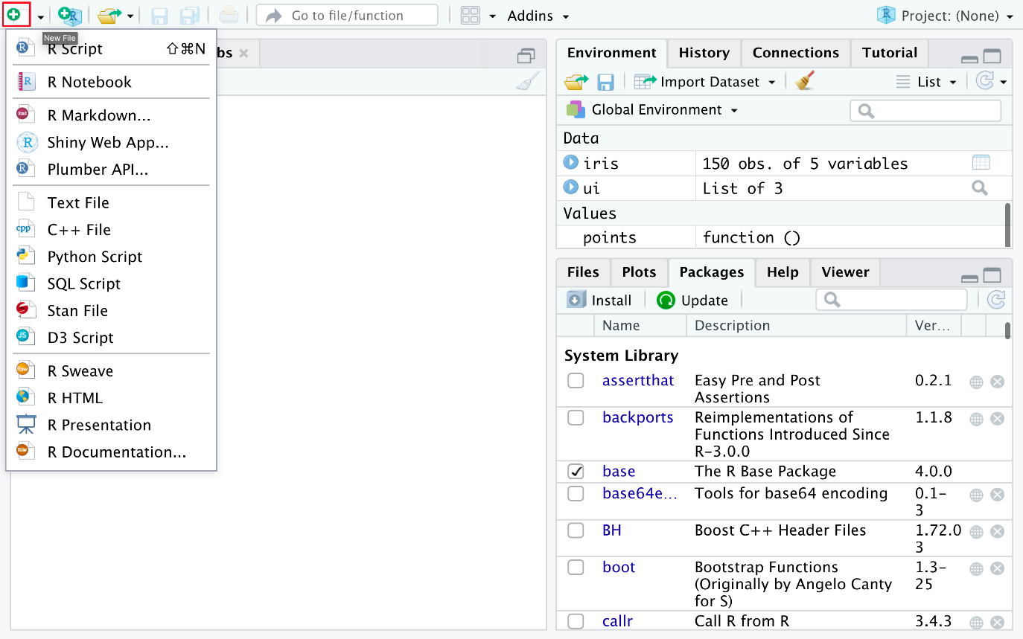

An untitled R Script panel opens. It would look like this.

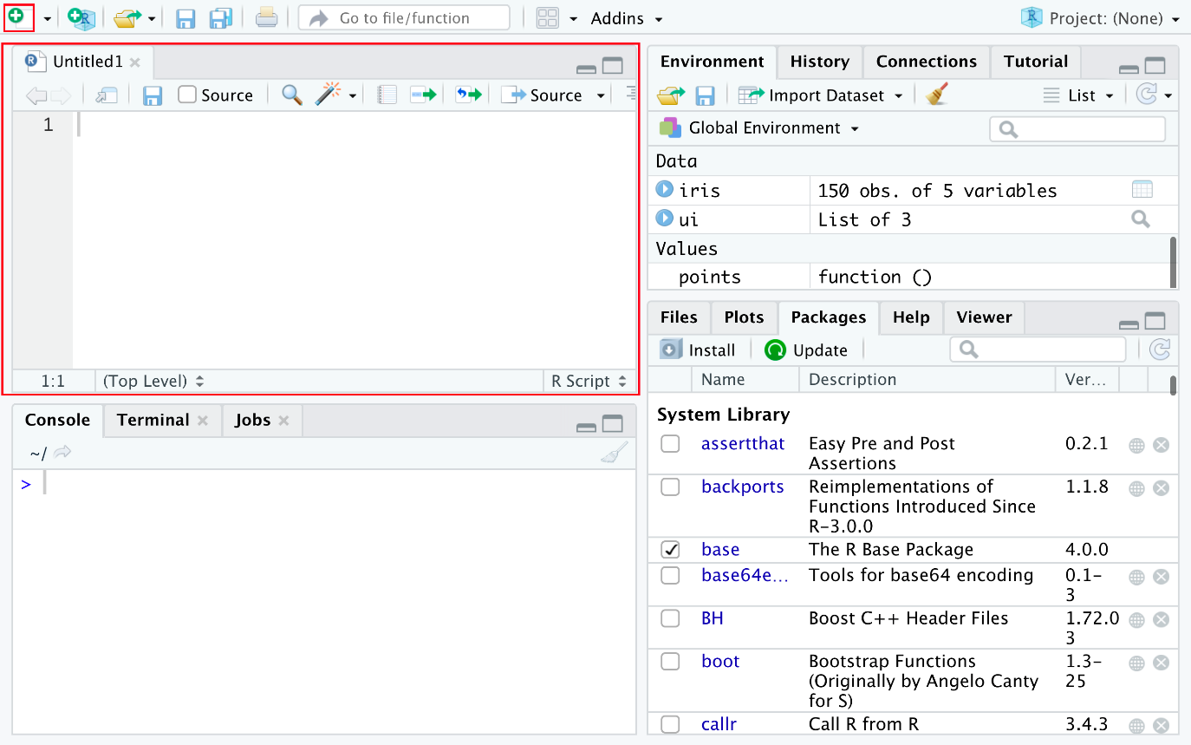

**Step 2** - Now you load the iris dataset. Enter the following lines into the editor window that appears. Then select all the text, and click Run just above the editor window.

1. 1
2. 2
3. 3
4. library (datasets)
5. data(iris)
6. View(iris)

Copied!Wrap Toggled!

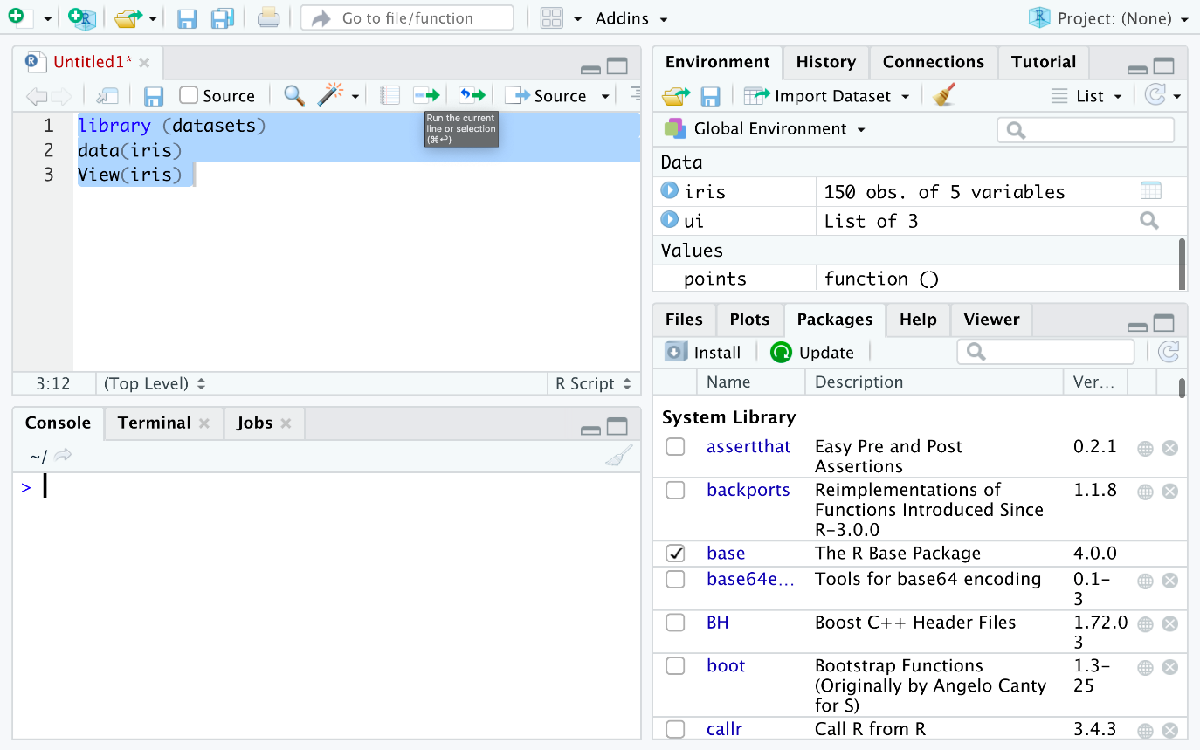

**Step 3** - You are taken to the data view tab to inspect your dataset. The dataset contains five columns and the first four are floating point type while the last column is a label of data type string which contains the category value. You can see there are total 150 entries of which you can see the first 7.

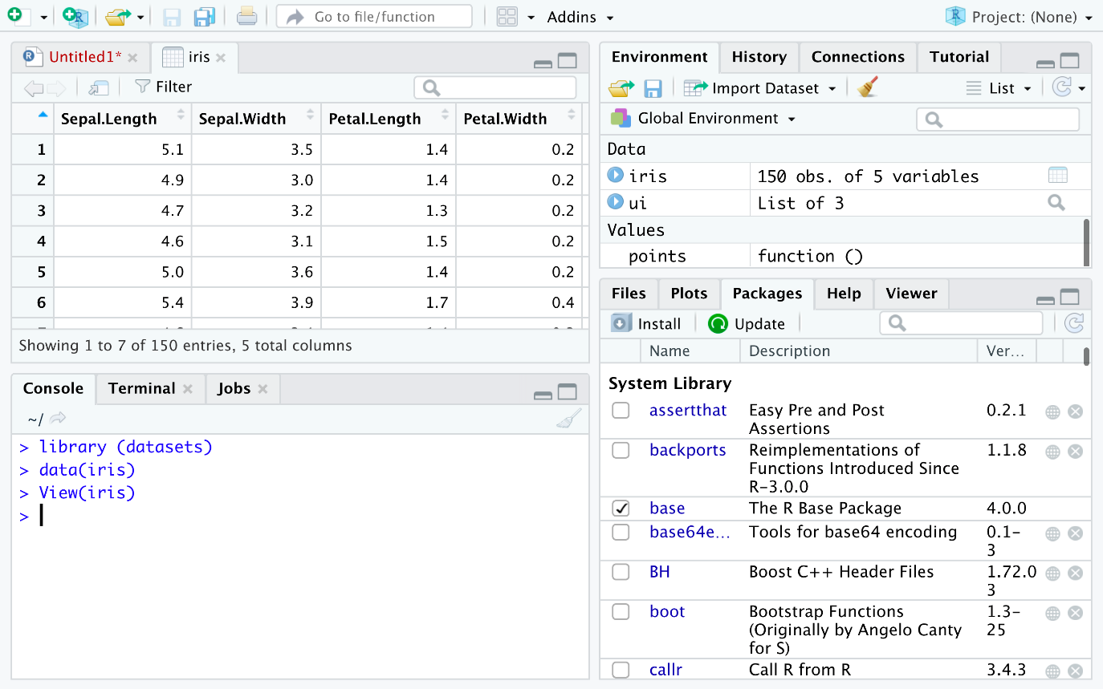

**Step 4** - Now you can find the different species present in the data set. Enter the following command in the editor window and click Run.

1. 1
2. unique(iris$Species)

Copied!Wrap Toggled!

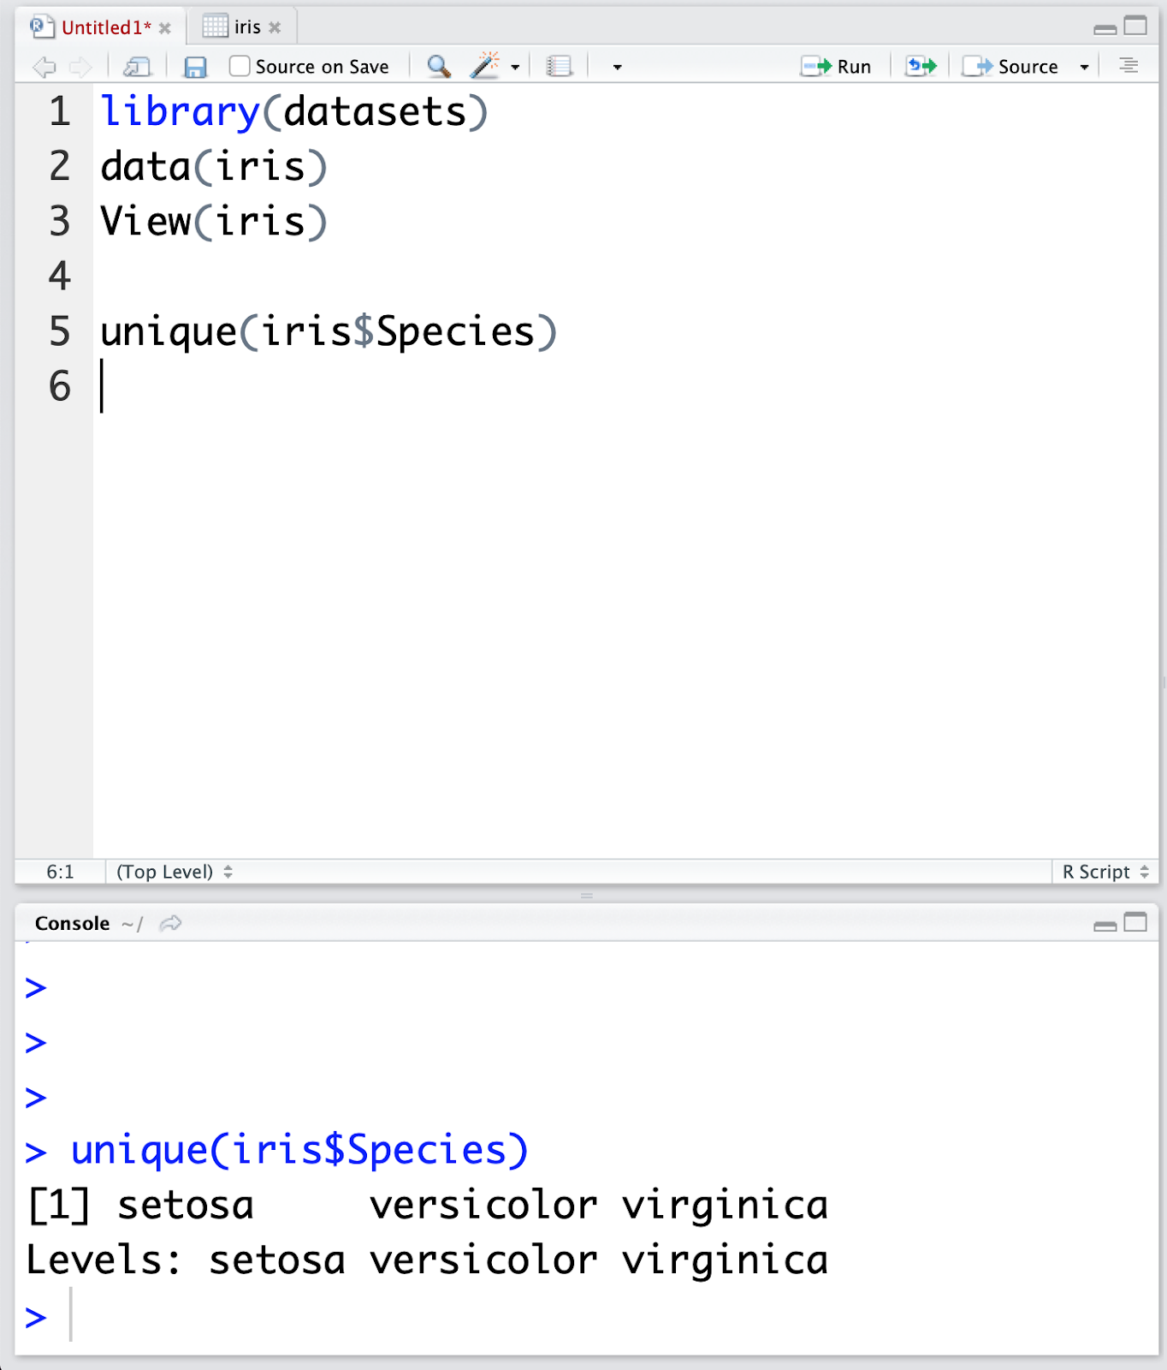

In the Console window at the bottom you can see the result of the executed command and know that there are only three different species present in the dataset.

This concludes the lab; I hope you enjoyed it!

**Creating Data Visualizations using ggplot**

In this lab, you will learn how to create some basic visualizations in R.

**Creating Data Visualizations using ggplot**



**Objective for Exercise**

We will create different data visualizations using the ggplot package using the inbuilt dataset in R called mtcars

1. Click on the + symbol on the top left and choose R Script from the menu to open a new R edit window in RStudio:

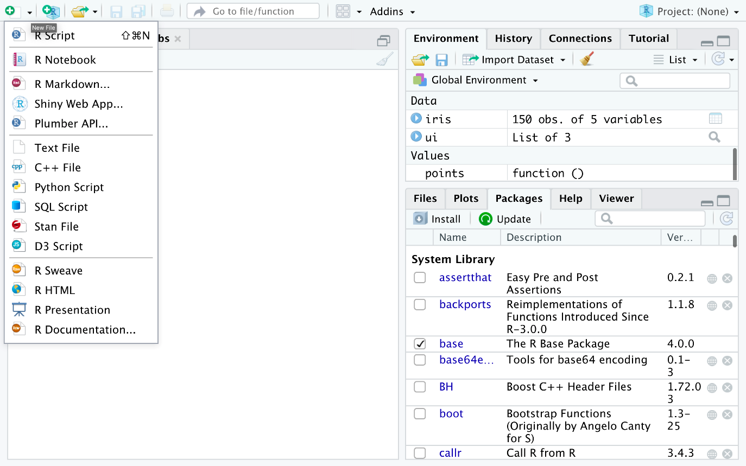

1. Read and view the first 5 rows of the Data using the following:
2. 1
3. 2
4. 3
5. 4
6. 5
7. 6
8. 7
9. 8
10. 9
11. library(datasets)
12. #Load Data
13. data(mtcars)
14. #View first 5 rows
15. head(mtcars, 5)

Copied!Wrap Toggled!

1. Type this ?mtcars to get information about the variables. This will print the information at the bottom right panel, on the Help tab
2. Copy and paste the following code to load the ggplot package and create a scatterplot of disp and mpg.
3. 1
4. 2
5. 3
6. 4
7. 5
8. 6
9. #load ggplot package
10. library(ggplot2)
11. #create a scatterplot of displacement (disp) and miles per gallon (mpg)
12. ggplot(aes(x=disp,y=mpg,),data=mtcars)+geom_point()

Copied!Wrap Toggled!

1. Use the following code to add a title.
2. 1
3. 2
4. 3
5. 4
6. #Add a title
7. ggplot(aes(x=disp,y=mpg,),data=mtcars)+geom_point()+ggtitle("displacement vs miles per gallon")

Copied!Wrap Toggled!

1. Use the following code to change the name of the x-axis and y-axis
2. 1
3. 2
4. 3
5. 4
6. #change axis name
7. ggplot(aes(x=disp,y=mpg,),data=mtcars)+geom_point()+ggtitle("displacement vs miles per gallon") + labs(x = "Displacement", y = "Miles per Gallon")

Copied!Wrap Toggled!

1. Use the following to create a boxplot of the the distribution of mpg for the individual Engine types vs Engine (0 = V-shaped, 1 = straight)  
   To do this you have to make vs a string or factor.
2. 1
3. 2
4. 3
5. 4
6. 5
7. 6
8. #make vs a factor
9. mtcars$vs <- as.factor(mtcars$vs)
10. #create boxplot of the distribution for v-shaped and straight Engine
11. ggplot(aes(x=vs, y=mpg), data = mtcars) + geom_boxplot()

Copied!Wrap Toggled!

1. Add color to the boxplots to help differentiate:
2. 1
3. 2
4. 3
5. ggplot(aes(x=vs, y=mpg, fill = vs), data = mtcars) +
6. geom_boxplot(alpha=0.3) +
7. theme(legend.position="none")

Copied!Wrap Toggled!

1. Finally, let us create the histogram of weight wt.
2. 1
3. ggplot(aes(x=wt),data=mtcars) + geom_histogram(binwidth=0.5)

Copied!Wrap Toggled!

This concludes this lab, we hope that you had fun!

**Plotting with RStudio**

This lab introduces you to advanced plotting with ggplot.

Skills Network Labs (SN Labs) is a virtual lab environment used in this course. Upon clicking "Open Tool" in accordance with IBM Skills Network Privacy policy your Username and Email will be passed to Skills Network Labs and will only be used for communicating important information to enhance your learning experience.



**Objective of Exercise:**

This lab introduces you to plotting in R with ggplot and GGally. GGally is an extension of ggplot2.

**Pre Requisite:**

Before loading the GGAlly package, ensure its dependencies are installed. Run the following commands in the Console window, as shown in the screenshot below, and then continue with the steps in the Exercise.

See Screenshot

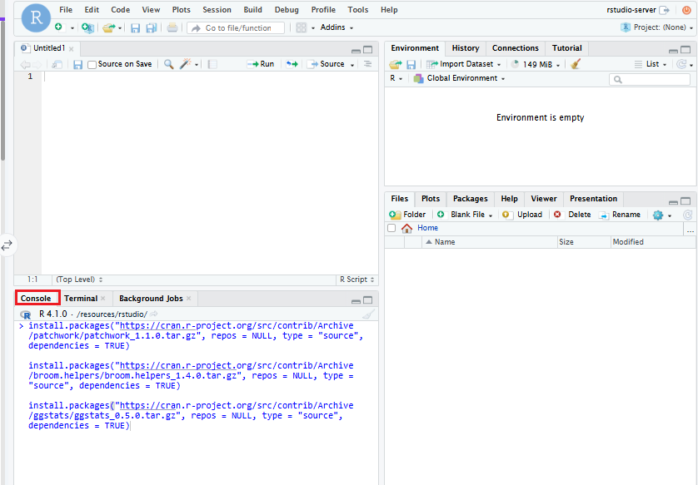

1. 1
2. 2
3. 3
4. 4
5. 5
6. install.packages("https://cran.r-project.org/src/contrib/Archive/patchwork/patchwork_1.1.0.tar.gz", repos = NULL, type = "source", dependencies = TRUE)
7. install.packages("https://cran.r-project.org/src/contrib/Archive/broom.helpers/broom.helpers_1.4.0.tar.gz", repos = NULL, type = "source", dependencies = TRUE)
8. install.packages("https://cran.r-project.org/src/contrib/Archive/ggstats/ggstats_0.5.0.tar.gz", repos = NULL, type = "source", dependencies = TRUE)

Copied!Wrap Toggled!

**Exercise:**

1. Click the plus symbol on the top left and click R Script to create a new R script, if you don't have one open already.



1. You will use the iris dataset. If you don't have it loaded, copy and paste the following into your R script file.
2. 1
3. 2
4. library(datasets)
5. data(iris)

Copied!Wrap Toggled!

1. In the previous lab, you installed the libraries necessary to create plots, let's execute the following commands:
2. 1
3. 2
4. library(GGally)
5. ggpairs(iris, mapping=ggplot2::aes(colour = Species))

Copied!Wrap Toggled!

1. Select the commands and click Run on the top. You' ll see the following plot in the **Plots** window:

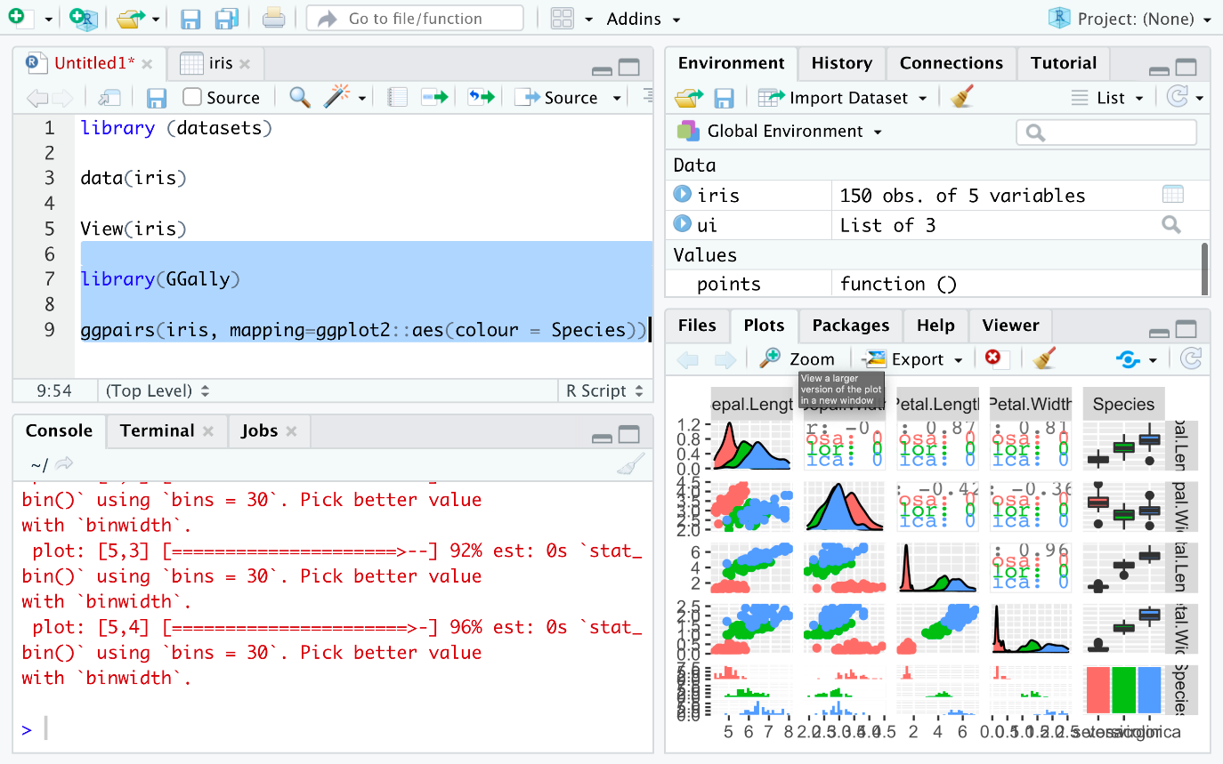

1. Click the **Zoom** icon on the plot window to zoom and see the plot.

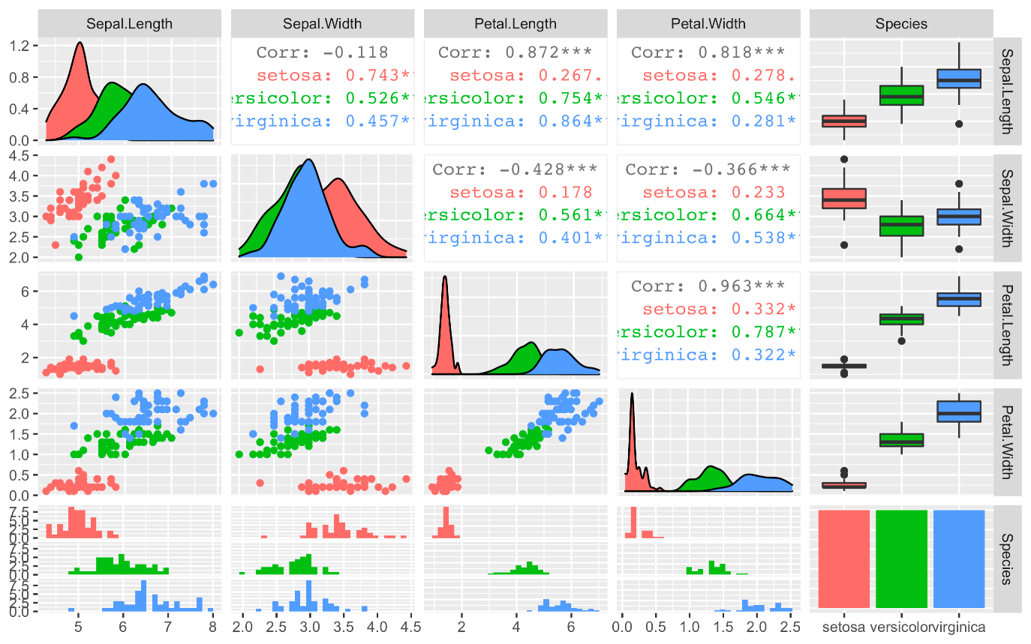

1. This gives you a lot of information for a single line of code. First, you can see the data distributions per column and species on the diagonal. Then you see all the pair-wise scatter plots on the tiles left to the diagonal, again segregated by color. It is, for example, obvious that a line can be drawn to separate **setosa** against **versicolor** and **virginica**. In later courses, you will also learn how the overlapping species can be separated. This is called supervised machine learning using non-linear classifiers. You can also see the correlation between individual columns in the tiles on the right to the diagonal, which confirms that **setose** is more different, hence easier to distinguish, than **versicolor** and **virginica**. A correlation value close to one signifies high similarity, whereas a value closer to zero signifies less similarity. The remaining plots on the right are called **box-plots**, and the ones at the bottom are called **histograms**, but you will learn about this in a more advanced course in this series.

